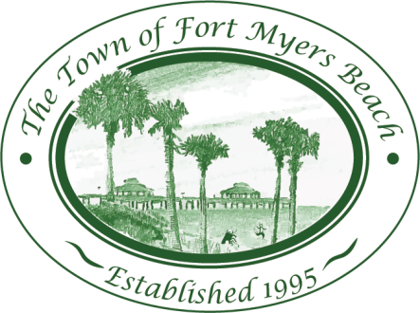
Town of Fort Myers Beach

LOCAL PLANNING AGENCY
Newton Park
4610 Estero Boulevard
Fort Myers Beach, Florida
33931
May 12, 2015

AGENDA (all time frames are informational and approximate) 9:00 AM

- Call to Order
- Invocation
- Pledge of Allegiance
- Minutes
  - Minutes of April 14, 2015 LPA meeting

- Public Hearing
  - SEZ014-0001 – Convert Seasonal Parking Lot to Year Round Parking Lot

- EAR Discussion
  - Review of Elements
    - Review Utilities
    - Review Stormwater Management Element
    - Review Public Schools Element
    - Envisioning Element
    - Community Design

- Post-disaster Recovery and Reconstruction Discussion

Adjourn as LPA and reconvene as Historic Preservation Board
  - Mound House Sign
Adjourn as Historic Preservation Board and reconvene as LPA
- LPA Member Items and Reports
- LPA Attorney Items
- Community Development Items
- LPA Action Item List Review
- Items for next month’s Agenda
- Public Comment
- Adjournment

Next Meeting: June 9, 2015

 | For special accommodations, please notify the Town Clerk’s Office at least 72 hours in advance. (239) 765-0202 |  | Help for the hearing impaired is available through the Assistive Listening System. Receivers can be obtained from the Town Clerk’s Office.

