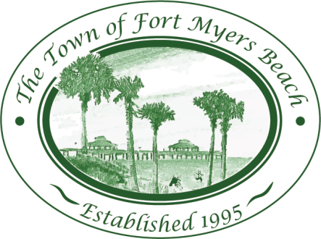
Town of Fort Myers Beach

LOCAL PLANNING AGENCY
Town Hall
2525 Estero Boulevard
Fort Myers Beach, Florida
33931
November 17, 2015

AGENDA 1:30 PM

- Call to Order
- Pledge of Allegiance
- Invocation

- Minutes
  - Minutes of September15, 2015 LPA meeting
  - Minutes of October 13, 2015 LPA meeting

- REZ2015-0002 & SEZ2015-0004 & VAR2015-0005
Convert seasonal parking lot to a permanent parking lot (SEZ). Rezone Lot 7 from RM to Downtown and include this part of the property in the Special Exception request to be utilized as a part of the shared parking lot, permanent (REZ). The application includes 4 requested variances (VAR). The first is from LDC section 10-416(d)(2) which requires a Type “D” Buffer (15 foot width with 5 trees per 100 linear feet and a 3 foot high double staggered row hedge) to allow a 1 foot wide buffer with a 4 foot high white picket fence. The second is from LDC section 34-1744 which states that any fence or wall located in a side or rear yard shall not exceed six feet in height, to allow an 8-foot high solid wall within 1 foot of the northern property line. The third requested variance is from LDC section 10-416(c)(2) which requires internal landscaping to allow landscaping as shown on the plan. The fourth requested variance is from LDC section 10-416(d)(2) Tables 10-8 and 10-9, which requires a Type “C” Buffer (minimum 15 foot wide, 5 trees and 18 shrubs per 100 linear feet & a screening wall) to allow for no buffer along the site’s west boundary.

- LDC Amendment:
  - Delete section 34-2022 - Seasonal parking lots

- EAR Discussion
  - Review of Elements
    - Review Procedures and Monitoring, mapping

- LPA Member Items and Reports
- LPA Attorney Items
- Community Development Items
- Items for next month’s Agenda
- Public Comment
- Adjournment

Next Meeting: December 8, 2015

 | For special accommodations, please notify the Town Clerk’s Office at least 72 hours in advance. (239) 765-0202 |  | Help for the hearing impaired is available through the Assistive Listening System. Receivers can be obtained from the Town Clerk’s Office.

