How to use the Customer Portal

The Customer Portal is a one-stop shop for managing your Short-Term Rental registration and tax remittance requirements. Through the Customer Portal, you can view, renew and update your existing permits and apply for new permits. You can also report and remit any applicable taxes and view your history of past remittances (where applicable).
Note that this guide will refer to “Permits”, but they may have a different name in your jurisdiction, like “Certificates” or “Licenses”. Likewise, your jurisdiction’s requirements and available features might be different – your Permit may not require renewal for example, or tax remittance may not be required for you. In all cases please refer to the department managing Short-Term Rentals in your jurisdiction.
This guide is intended to help you through the process of visiting the portal for the first time, creating an account (if necessary), applying for a new permit, updating your permit details, renewing a permit, and reporting and remitting the required tax.
To skip to a particular section of the guide, just use the links below. Otherwise, read through for a comprehensive overview of the customer portal and how to use it.
- Getting started
- Creating a new account
- Logging in to the portal
- Editing your account details
- Logging out of the portal
- Applying for a new permit
- Updating details of a permit
- Renewing your permit
- Reporting and remitting tax
- Viewing your reporting history
- Getting additional help

Getting started
If you don’t have any Short-Term Rental permits yet and wish to apply for one, you’ll need to create an account on the portal to get started. Follow the instructions in the Creating a new account section below.
If you have existing STR permits in this specific jurisdiction which were created using a previous registration system, we have already created an account for you. Follow the instructions in the Logging in to the portal section.

Creating a new account
If you don’t have an existing portal account, you’ll need to create one before you can apply for an STR permit. Please note that if you already hold STR permits from this specific jurisdiction which were created using a previous registration system, we have already created an account for you as part of the transition to the new Customer Portal. You can skip straight to the Logging in to the portal section.
To create your new account, navigate to the Customer Portal website for your jurisdiction. You may wish to bookmark this page for future use.
Click the “Create new account” button on the left side of the page.

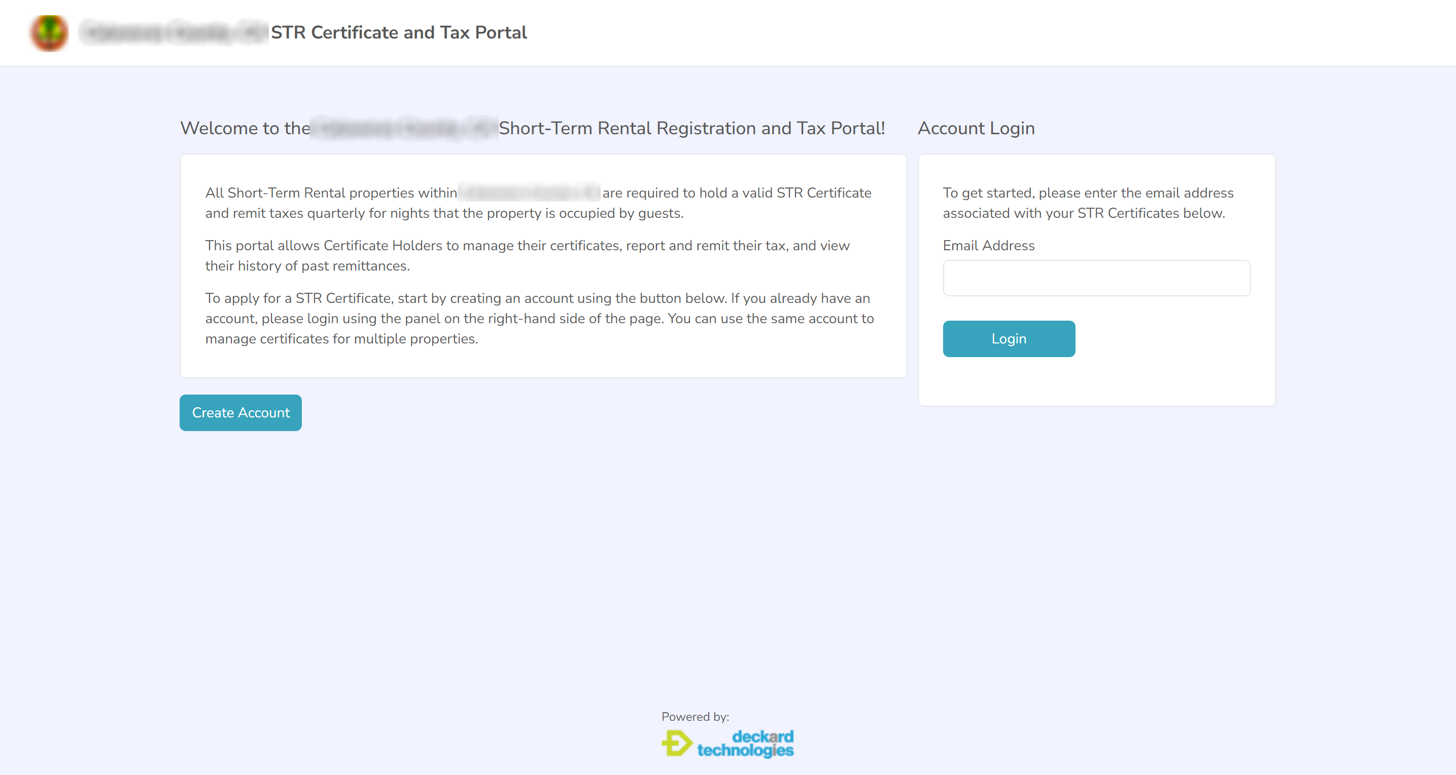

This will show the first screen in the process, which looks something like this:
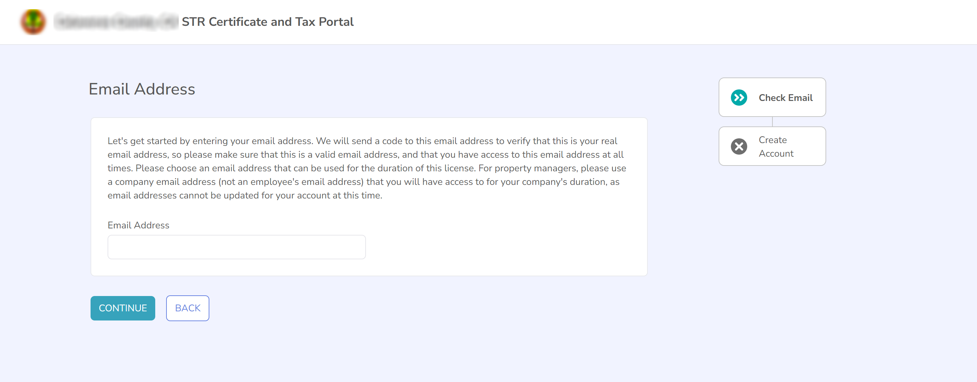
Enter your email address into the box and hit the “Continue” button. Please note that our Customer Portal does not use a password for login and instead sends a One-Time Code to your email address to verify that the correct person is logging into thhe account – this means that you should enter an email address that you will have ongoing access to. This is also the email address that will receive confirmation emails and receipts for your activity on the portal.
You will now be asked to enter your personal details. The screen will look similar to this:
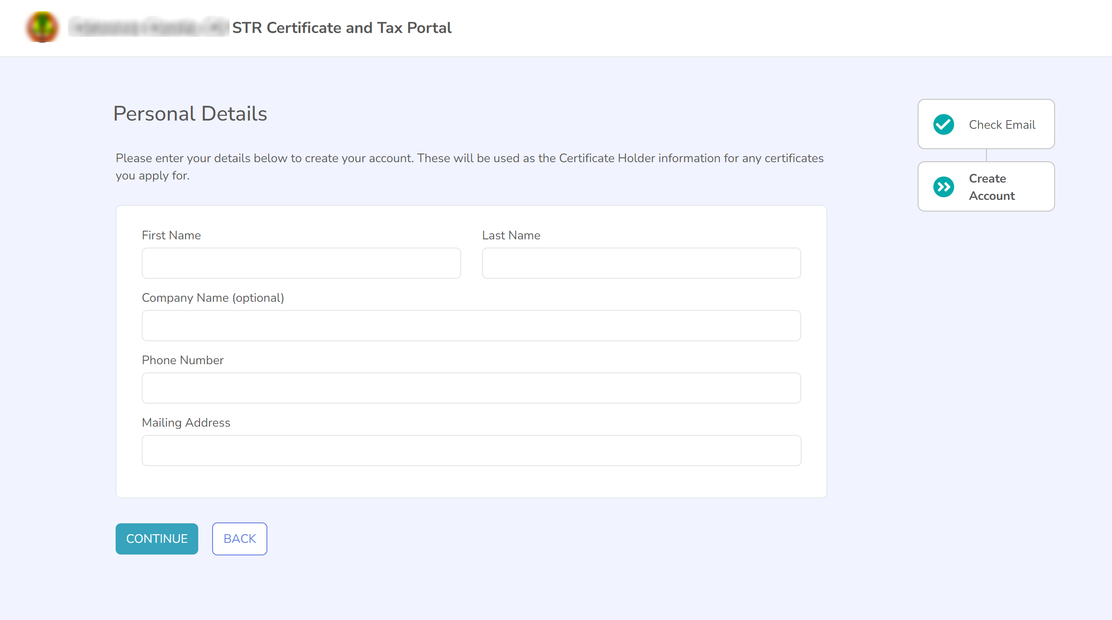

These details will be used as the permit holder details for any permits that you apply for, so make sure that you enter them correctly.
When you are creating your account, please keep in mind:
- When entering your Mailing Address, start typing your address into the provided textbox and you will see address suggestions. You’ll need to select one of the suggested addresses by clicking on it to set your address.
Once you’ve entered your personal details, click on the “Continue” button to move to the next step in the process.
Next we will ask you to verify that your email address is a real email address that you will be able to use to login to the site in future. You will see a screen that looks similar to the below:
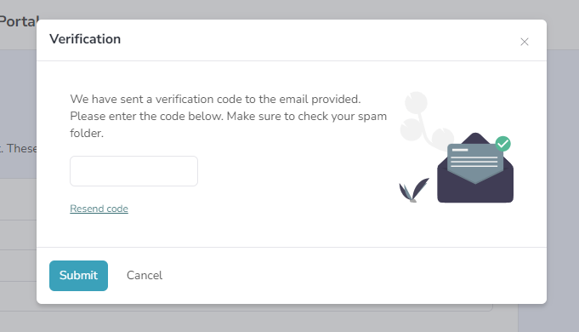

We will also send you an email to your email address that looks similar to this:
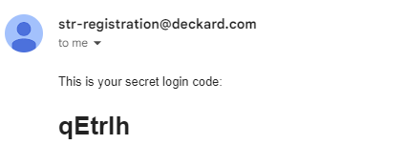
You’ll need to retrieve the secret login code from your email and enter it into the field provided.
When doing this please keep in mind:
- If you have not received an email, double-check that you are checking the correct email address, and that the email has not landed in your spam folder.
- You can either copy and paste this code directly from the email (recommended), or you can type it into the box. If you’re typing the code, please note that it is case sensitive so you will need to enter capital and lower-case letters correctly exactly as per the code in your email.
- From the time the email is sent, you have five minutes to retrieve and enter the code and move to the next stage in the process before the code expires – this is a security measure for your protection. If you haven’t managed to enter the code before the code expires, you can click the “Resend code” link to get a new one.
Once you have verified your email address, your account will be successfully created. At this point you will see the Dashboard screen, which looks similar to the below image. This is your home base for interacting with the Customer Portal and allows you to access all of the portal’s functionality.
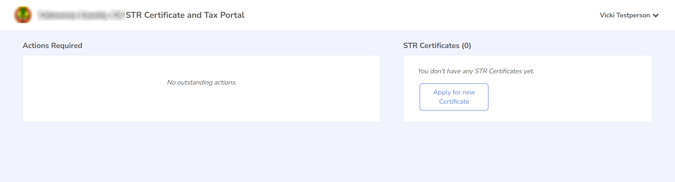

Logging in to the portal
If you already have a portal account (either because you created one on an earlier visit or because you created permits through the previous registration system and we automatically created an account for you), you can login to the portal directly from the landing page. To login to the portal, navigate to the Customer Portal website for your jurisdiction. You may wish to bookmark this page for future use.

In the Account Login section on the right-hand side of the page, enter your email address in the box provided and click on the “Login” button.
As part of the login process, we will verify that you are the correct person attempting to login to your account by sending you a secret login code to your email address. You will see a screen that looks similar to the below:
We will also send you an email to your email address that looks similar to this:
You’ll need to retrieve the secret login code from your email and enter it into the field provided.
When doing this please keep in mind:
- If you have not received an email, double-check that you are checking the correct email address, and that the email has not landed in your spam folder.
- You can either copy and paste this code directly from the email (recommended), or you can type it into the box. If you’re typing the code, please note that it is case sensitive so you will need to enter capital and lower-case letters correctly exactly as per the code in your email.
- From the time the email is sent, you have five minutes to retrieve and enter the code and move to the next stage in the process before the code expires – this is a security measure for your protection. If you haven’t managed to enter the code before the code expires, you can click the “Resend code” link to get a new one.

After you have entered your secret code successfully, you are logged in to the site. At this point you will see the Dashboard screen, which looks similar to the below image. This is your home base for interacting with the Customer Portal and allows you to access all of the portal’s functionality.

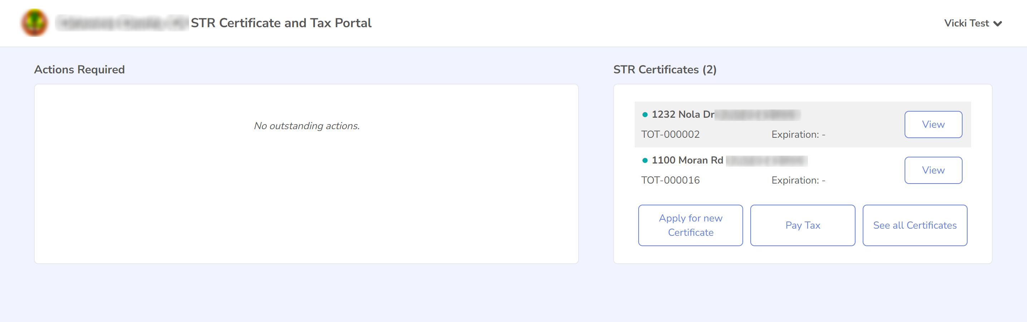
To learn more about using the portal, continue reading this guide.

Editing your account details
If any of your personal details such as your mailing address or phone number have changed, you can edit your account details to update this information. Please note that the details you enter will apply to all permits that are attached to this account, so you only need to update them once even if you have multiple permits.
Please note that if you wish to update the details of a specific permit such as the Property Manager information, please instead follow the instructions in 7. Updating details of a permit.
To begin, click on your name in the top right corner.
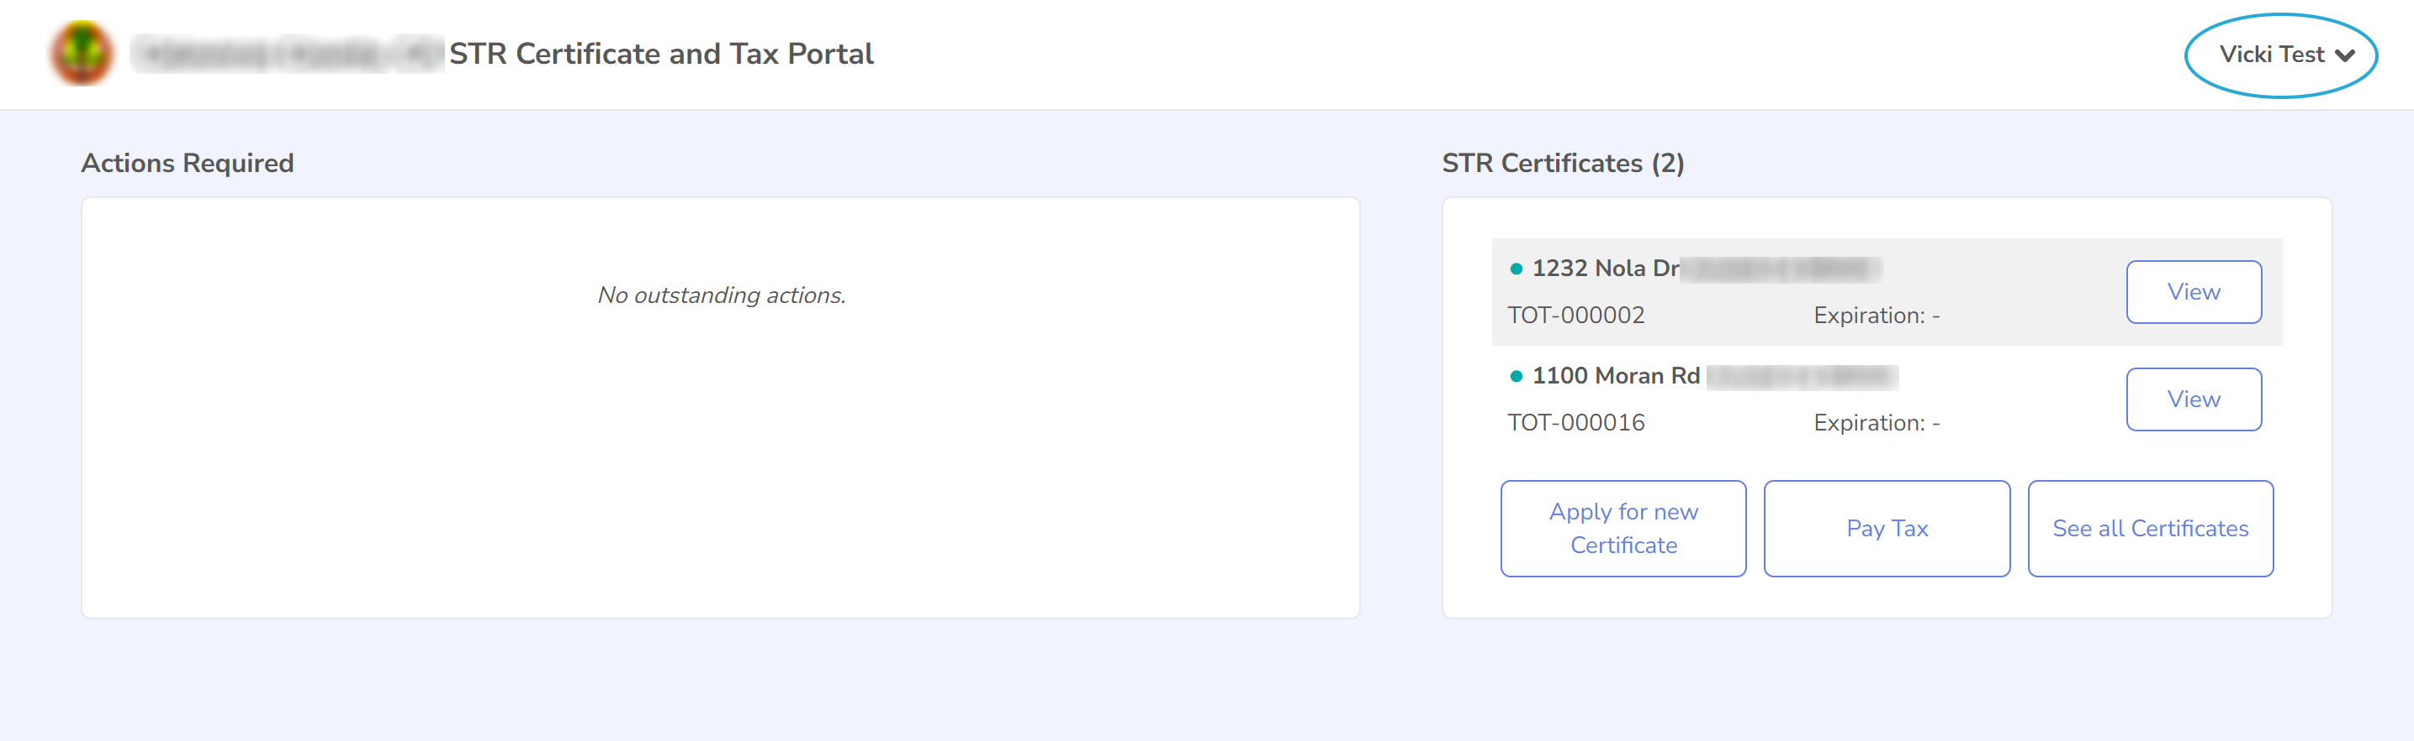
A dropdown menu will be displayed. Please select “Change my personal details”.
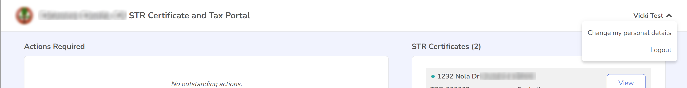
This will display the “Update Details” page, which should look like the following:

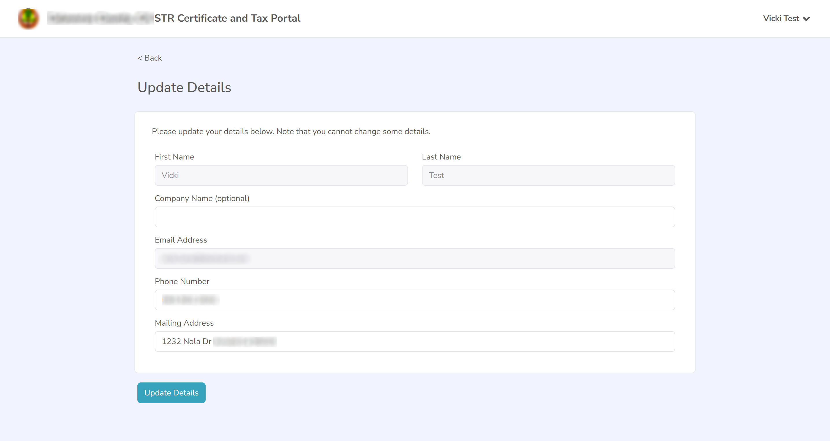
On this page you can change your company name, phone number and mailing address. Please note that you can’t change your first or last name as this is the name attached to the permit, or your email address as this is attached to your login. If you want to change your first or last name due to a legal name change, or change your email address, then please contact the staff of your jurisdiction.
When you are finished making any necessary changes, press the “Update Details” button. You will see a message that warns you that any changes made to your personal details will affect all of your permits. Press the “Continue” button if you are happy for these changes to apply to all permits.
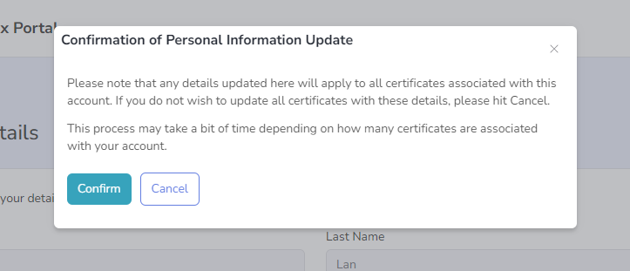
You will now return to the dashboard page where you’ll see a message indicating that your update of details was successful.

Logging out of the portal
Once you’ve finished using the Short-Term Rental Registration Portal, if you wish you can logout of your account to keep your account secure.
To logout of the portal, click on your name in the top right corner.
A dropdown menu will be displayed. Please select Logout.

Once you’ve successfully logged out of the portal, you will be returned to the initial landing page where you can choose to login again or leave the page.

Applying for a new permit
To start the process of applying for a new permit, you can click on the “Apply for a new Short-Term Rental Registration” button on the Dashboard.
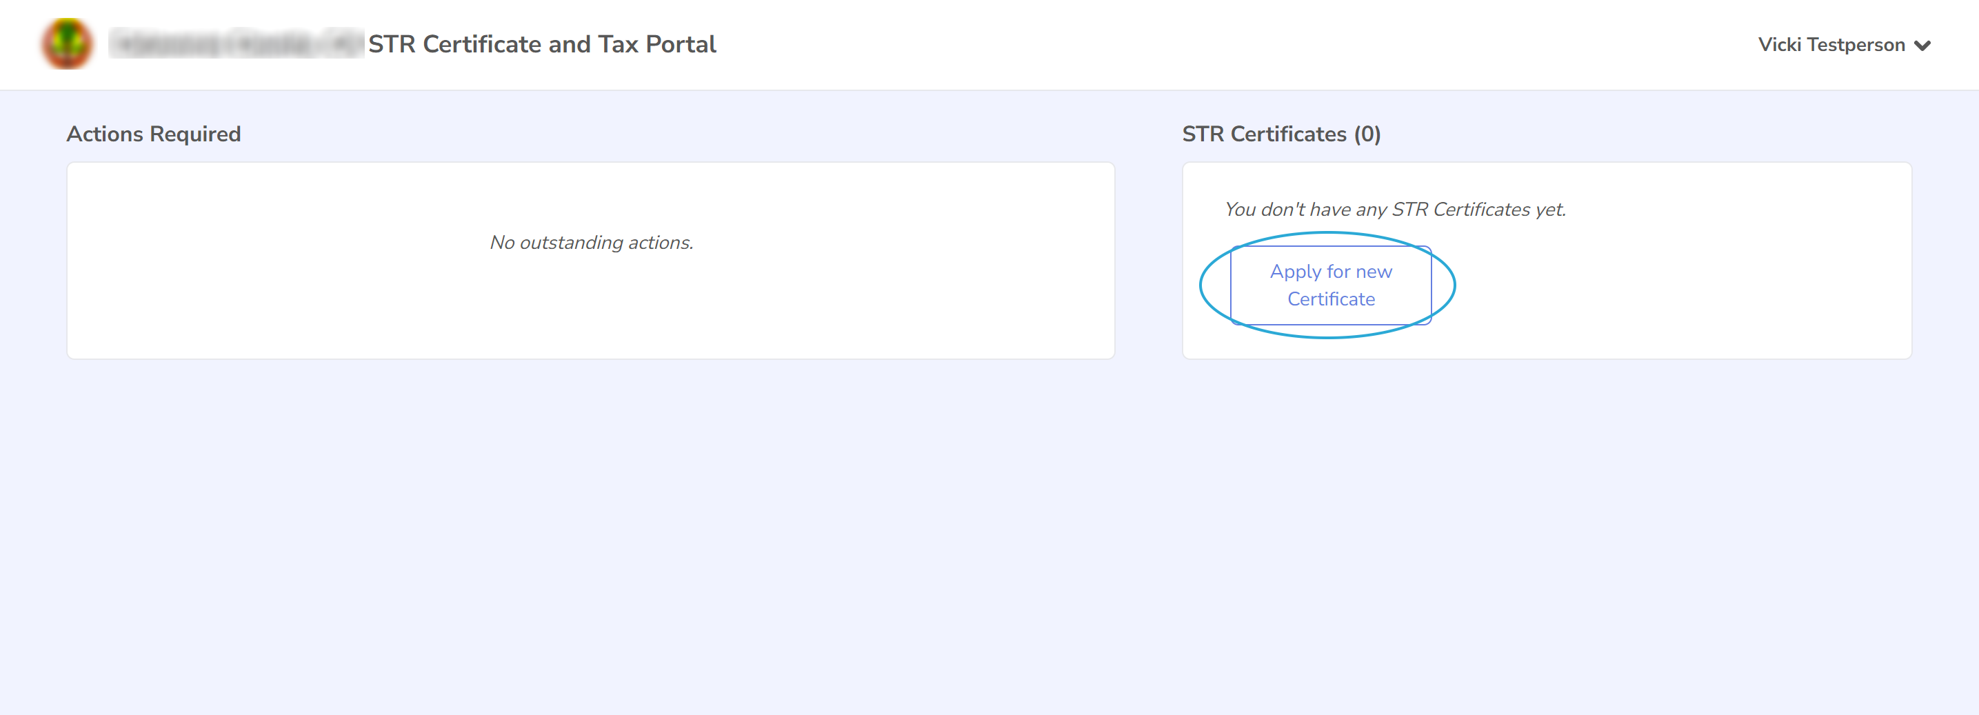

This will display the first page of the application process, which explains the requirements of the application process (which will differ depending on your jurisdiction). On the right-hand side of the page you will see a list of steps in the application process, this will update as you complete steps in the process.
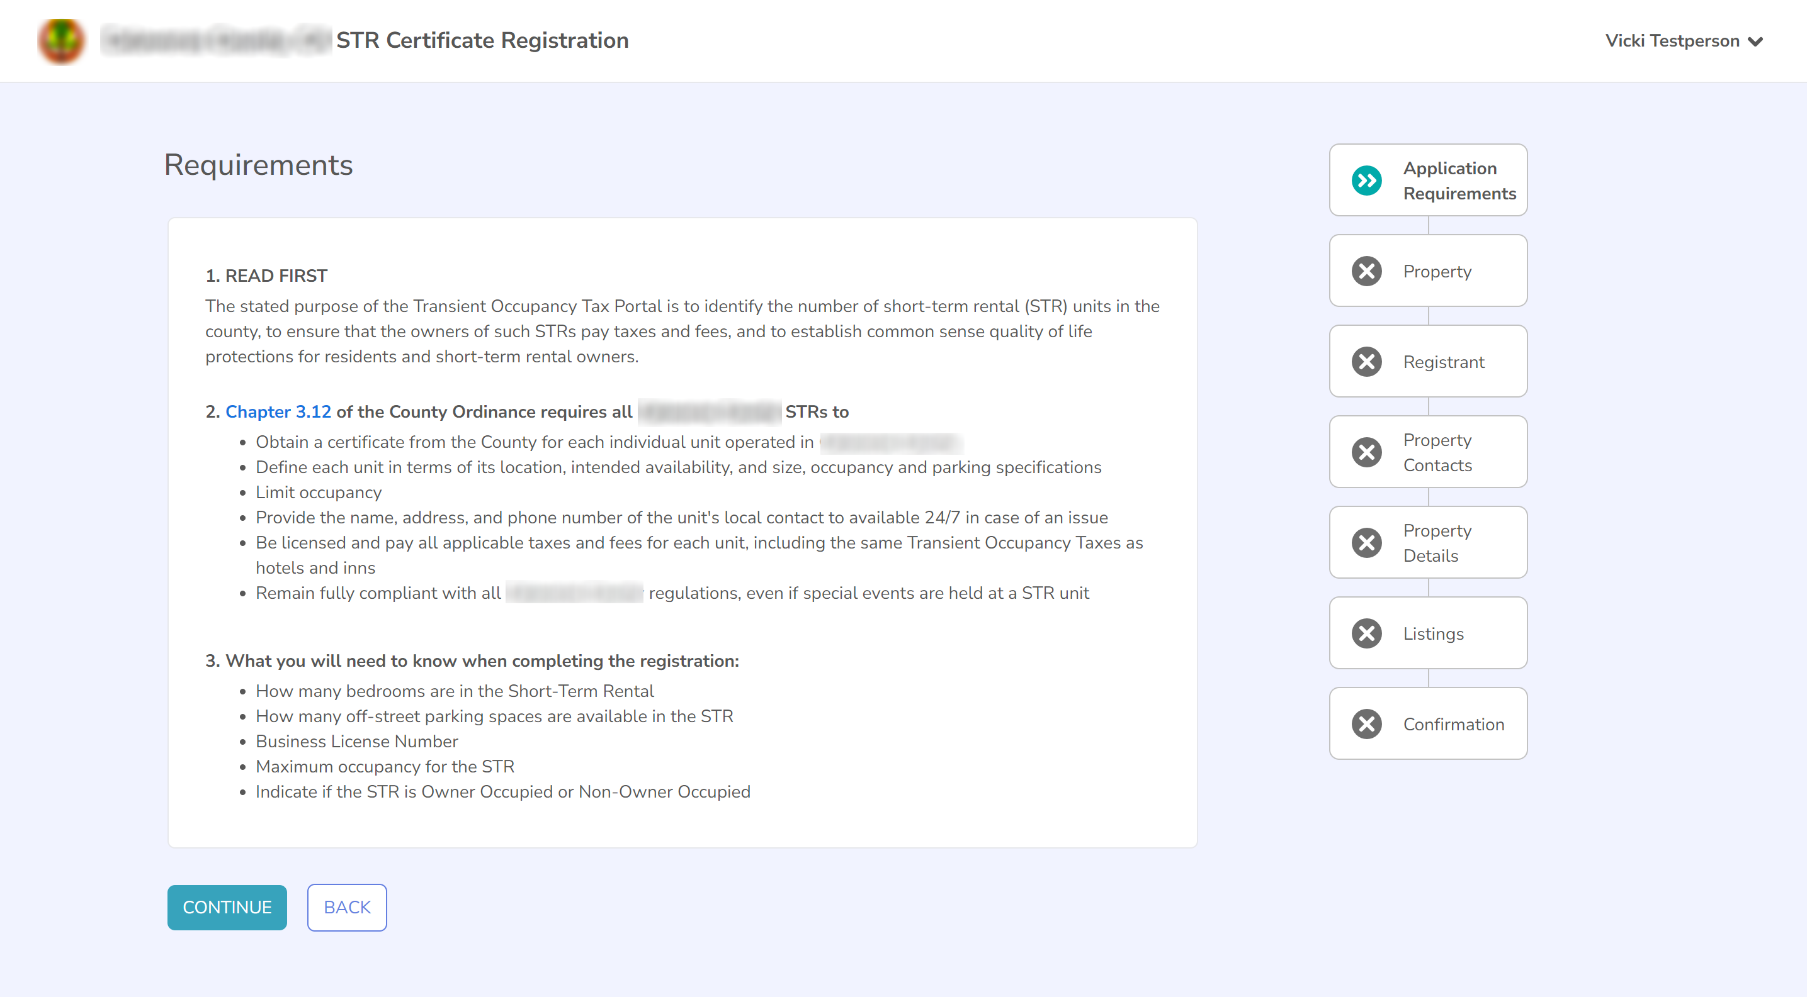
To apply for your permit, continue through this process completing all interim steps including the payment step. Once you reach a page that says “Thank you!” “Your short-term rental permit application has been submitted successfully!”, you have completed the full application process and will receive an email confirming your application details and your payment amount.
Your application will then be reviewed by the staff of your jurisdiction, and you will receive another email when your application is either approved or denied.

Updating details of a permit
If you wish to update the details of a specific permit such as the Property Manager or Local Contact information, please follow the instructions in this section. If you want to update your personal details such as your address, phone number or email address, please instead follow the instructions in 4. Editing your account details.
To update the details of a specific permit, you’ll first need to identify the permit you wish to update. On the dashboard, there is a list of your permits on the right-hand side of the page. If the permit you wish to update is in this list, click the “View” button attached to that permit to navigate to the detailed view of that permit.
If the permit you wish to update is not in that list, click on the “See all Permits” button to view a full list of all of your permits. Once you’ve found the permit that you wish to update, click on the “View” button attached to that permit to navigate to the detailed view of that permit.

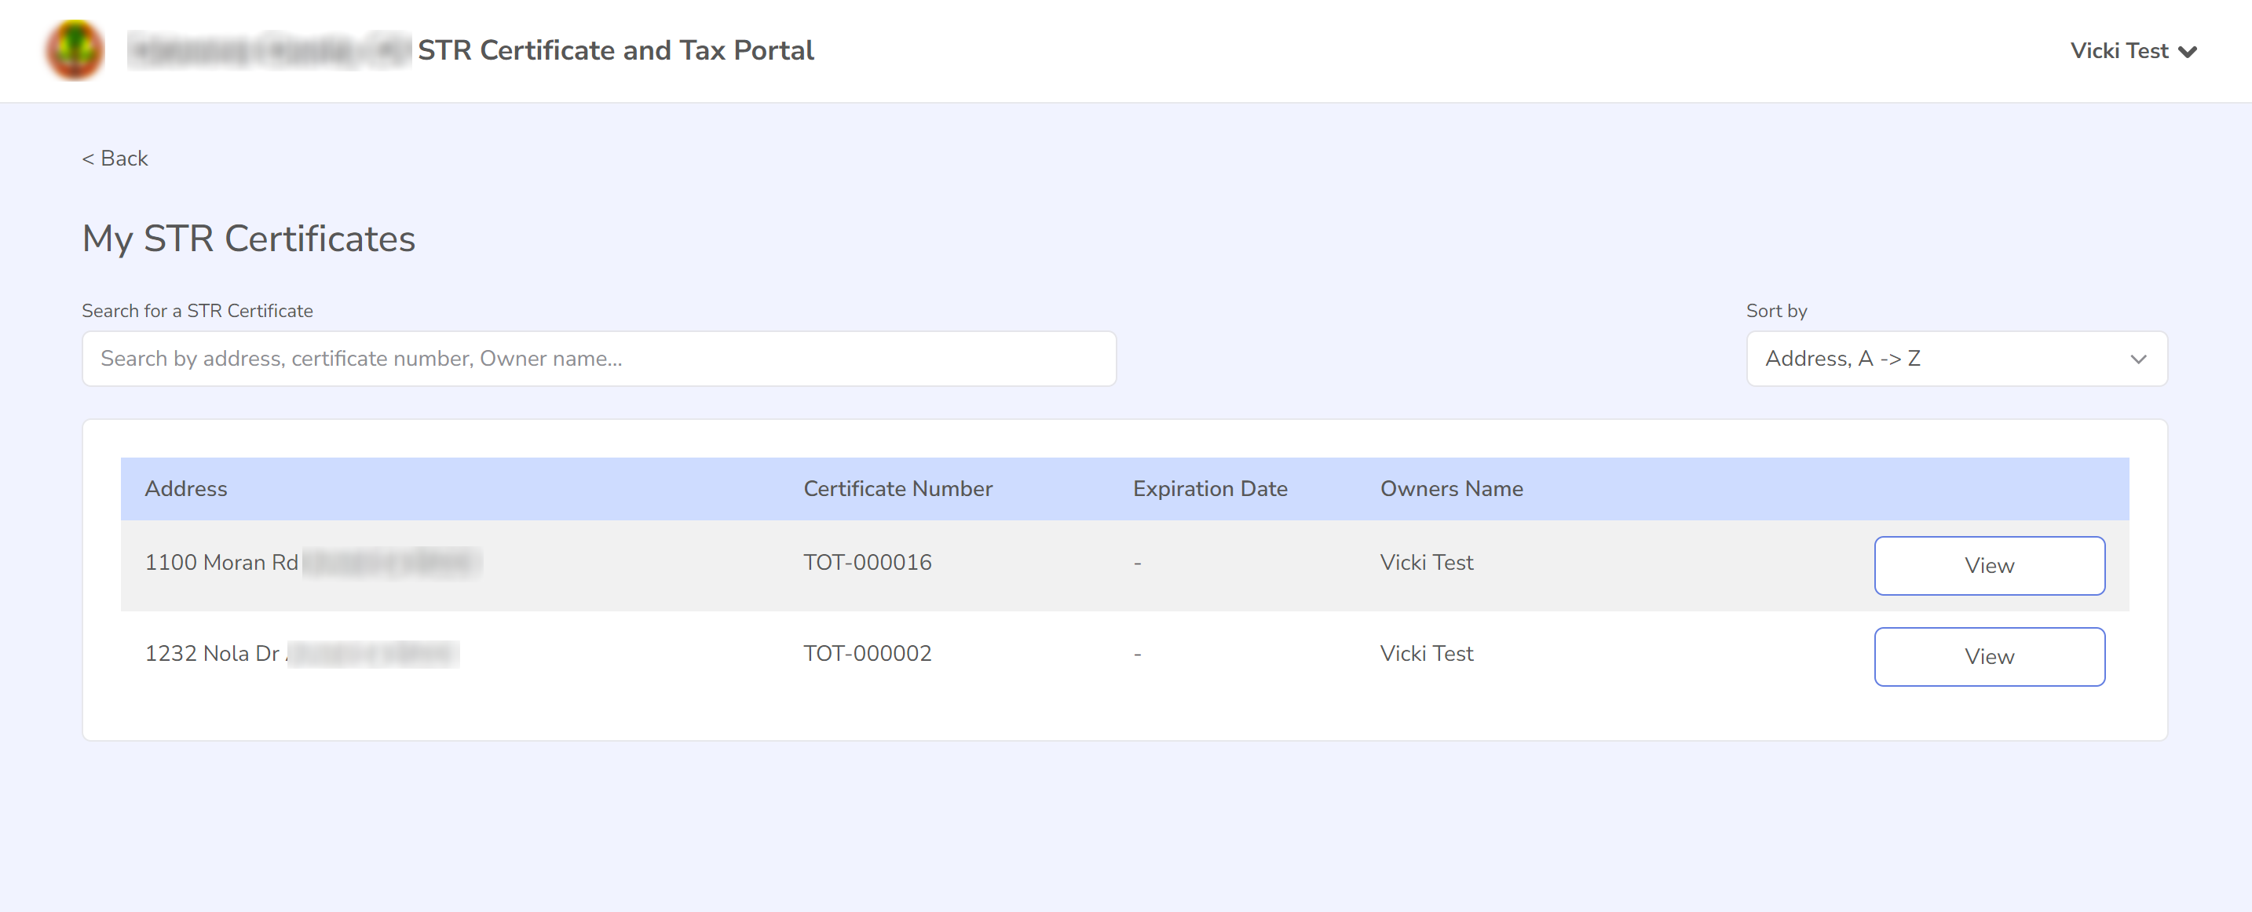

You should see a page showing the specific information about that permit, including the address, permit number and property contacts. Click on the “Update Permit Details” button in the top right-hand corner of the page.
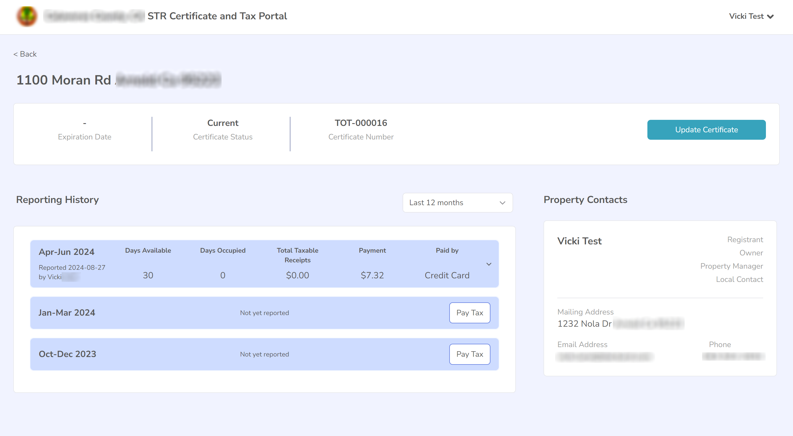

This will launch the Update flow process where you can update the Property Manager and Local Contact details and other details relevant to your jurisdiction.
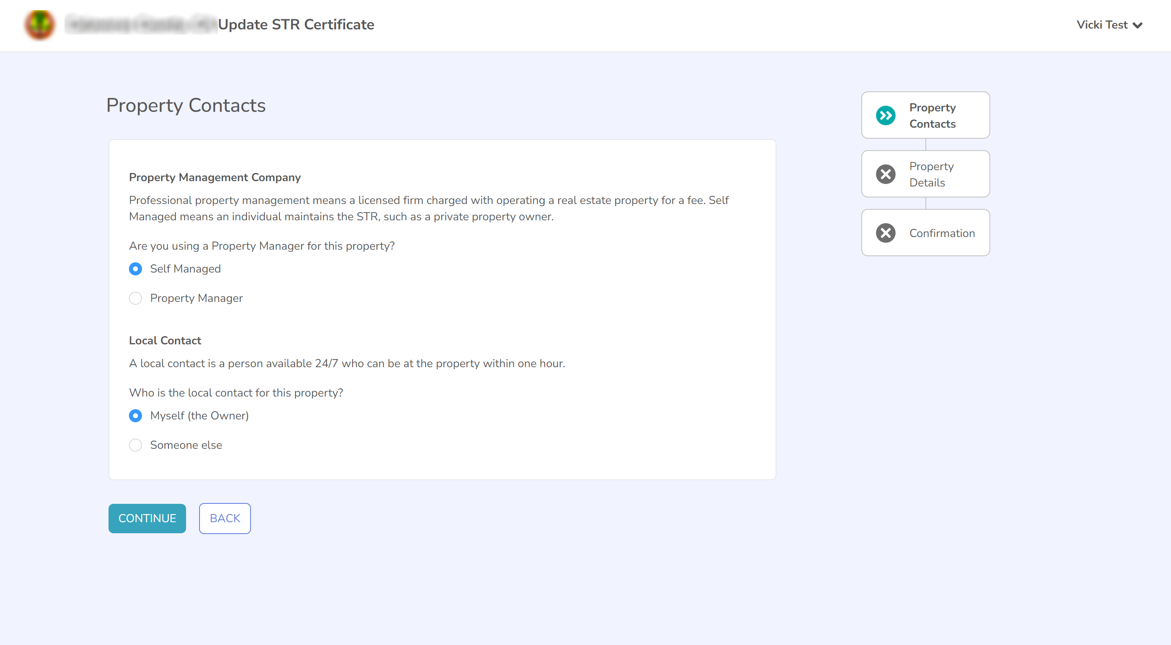

Renewing a permit
On the dashboard, there is an “Actions Required” box at the top-left of the page. If a permit is able to be renewed, it will be listed in this box with a button that says “Renew” next to it. You can click the “Renew” button to start the process of renewing this permit.
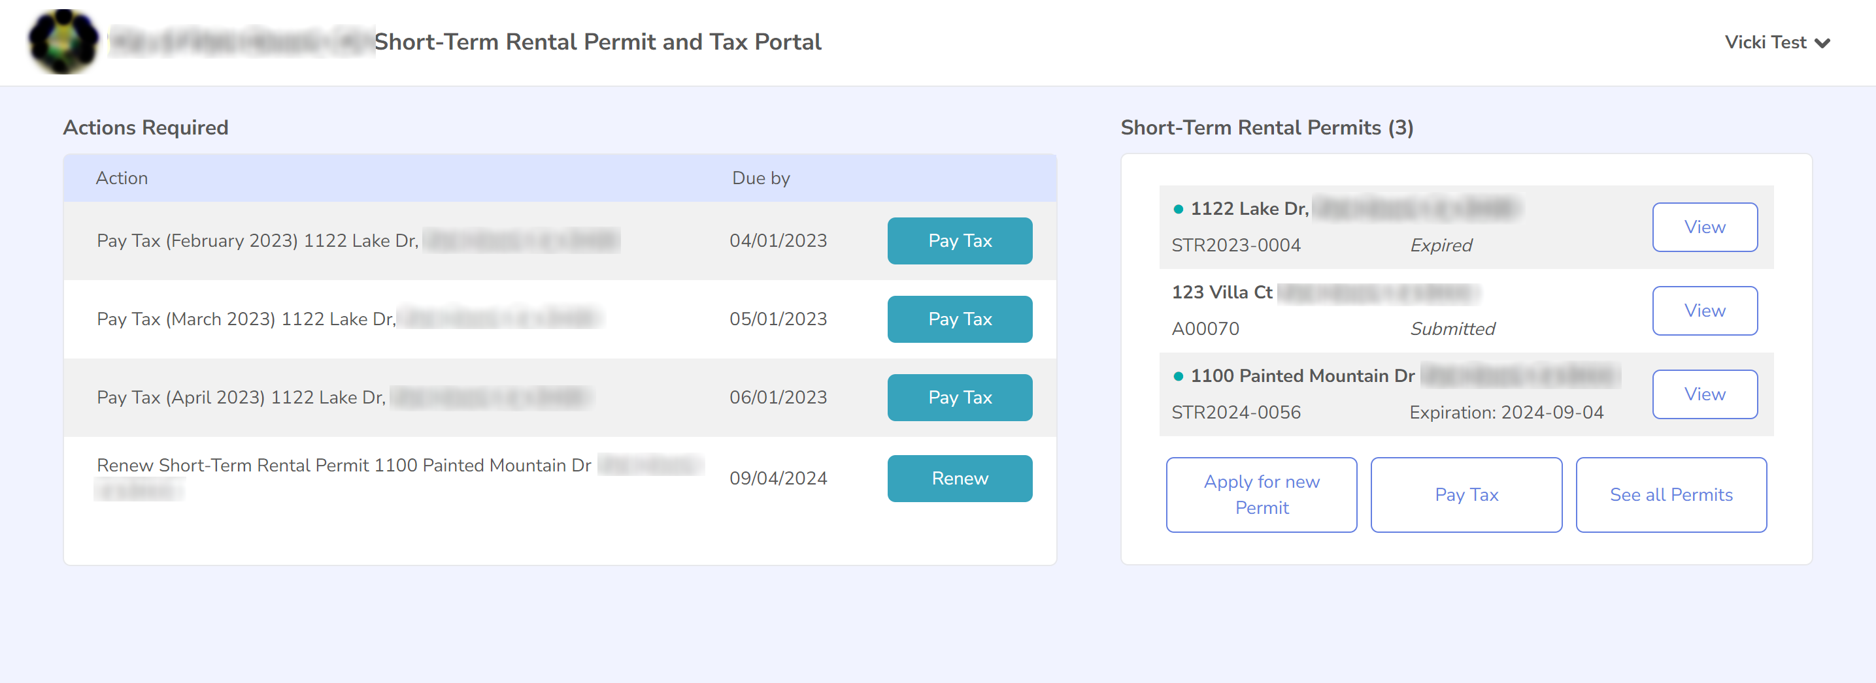

A “Renew Permit” button will also be located on the individual permit’s page. On the dashboard, there is a list of some of your permits on the right-hand side of the page. Click on the “See all Permits” button to view a full list of all of your permits. Then select “View” on the permit you wish to renew.
If a permit is renewable, a “Renew Permit” button will be visible on the right-hand side of this page next to the “Update Permit Details” button. If there is no “Renew” button, your permit is not able to be renewed at this time. To begin the process of renewing the permit, click on this “Renew Permit” button.
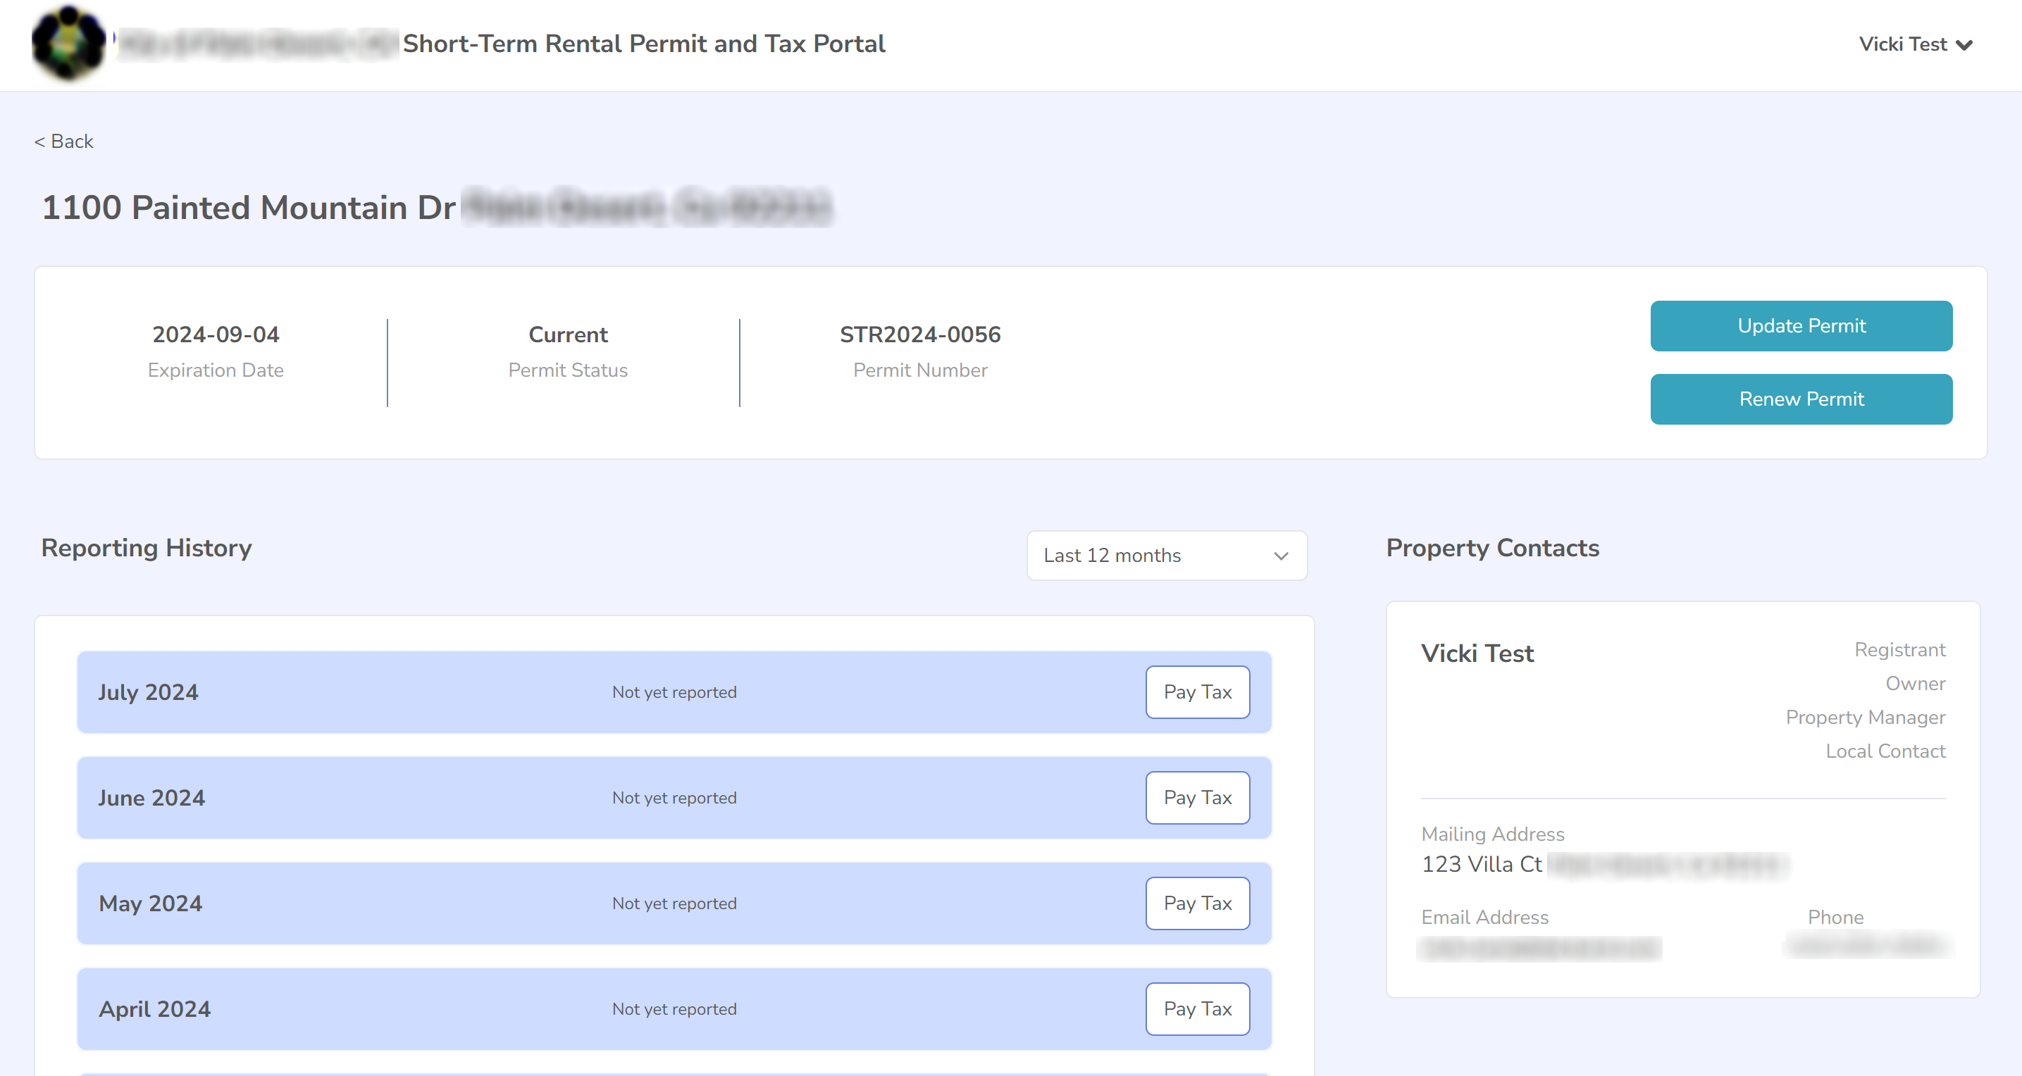

This will display the first page of the renewal process, which explains the requirements of the renewal process. On the right-hand side of the page you will see a list of steps in the renewal process. This will update to show you where you’re up to as you complete steps in the process.
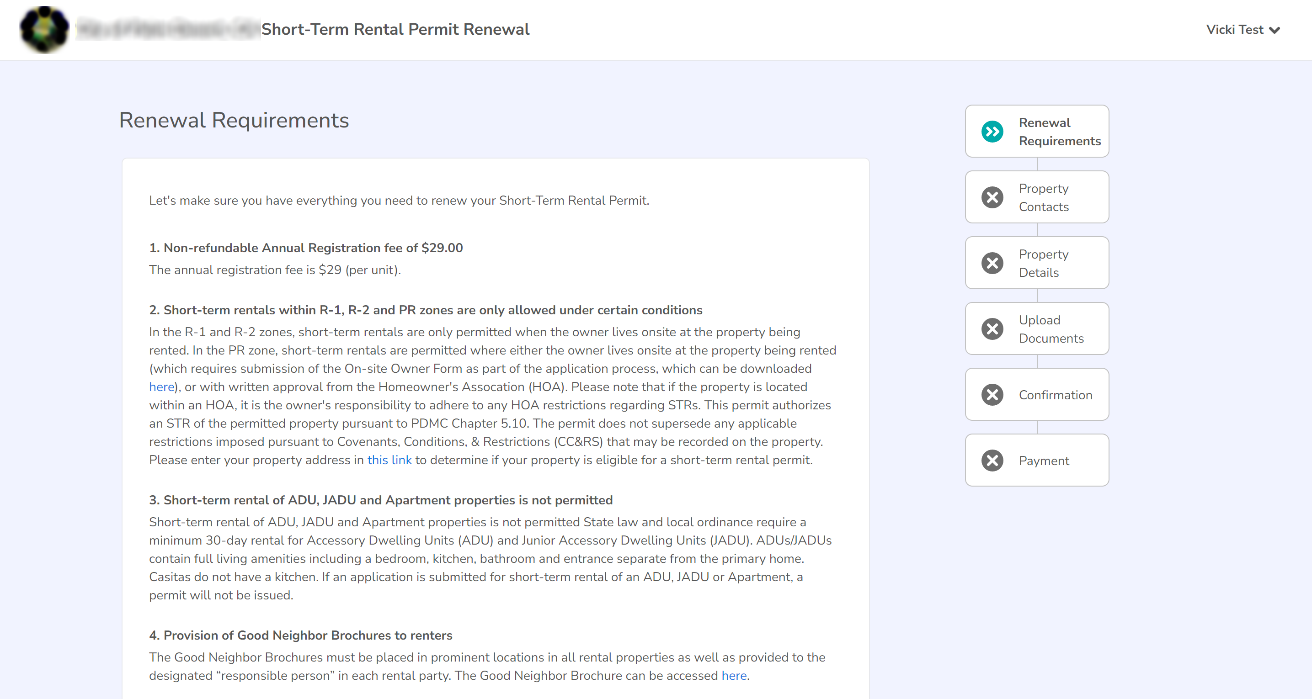
To renew your permit, continue through this process completing all interim steps including the payment step. Once you reach a page that says “Thank you!” “Your short-term rental permit renewal application has been submitted successfully!”, you have completed the full renewal process and will receive an email confirming your renewal details and your payment amount.
Your renewal will then be reviewed by the staff of your jurisdiction. You will receive another email when your renewal is either approved or denied.

Reporting and remitting tax
If required for your jurisdiction, the Customer Portal allows you to report and remit the taxes relevant to operating your short-term rental property, and view your reporting history.
On the dashboard, there is an “Actions Required” box at the top-left of the page. If a tax period is ready for reporting, it will show up here as a required action. If you have multiple properties that require reporting in a specific tax period, you can report and remit for both properties at the same time. You can click the “Pay Tax” button to begin the reporting process.

Select Properties for Tax Reporting
If you have more than one permit, you will see the “Select Properties for Tax Reporting” screen, which allows you to select one or more properties for reporting in this reporting period. By default, all properties with outstanding reporting in this period will be selected.
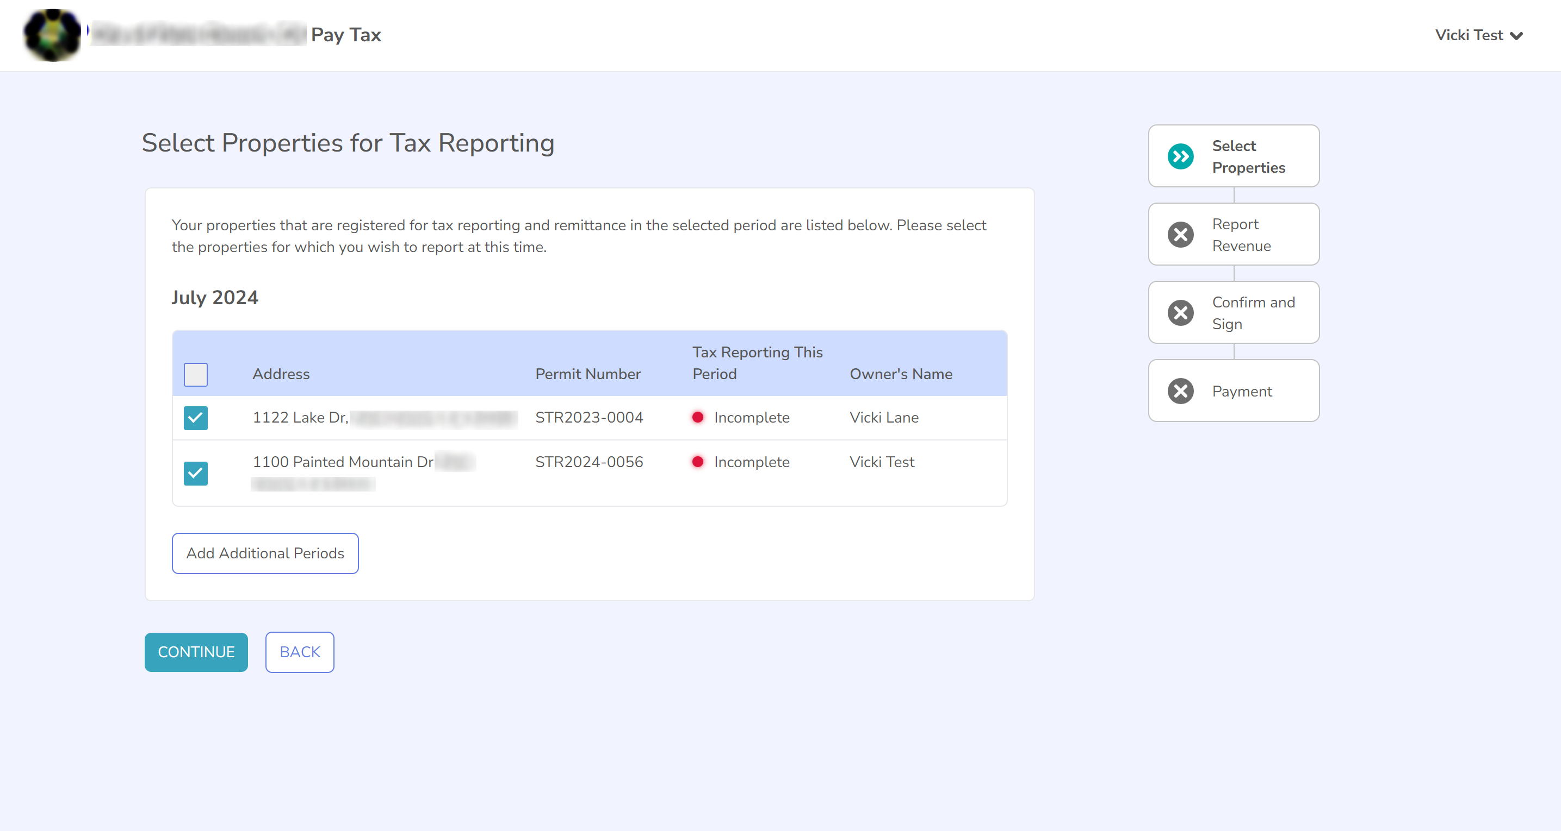
If you want to report additional periods, click the “Add Additional Periods” button under the table which will bring up a window allowing you to select additional reporting periods.
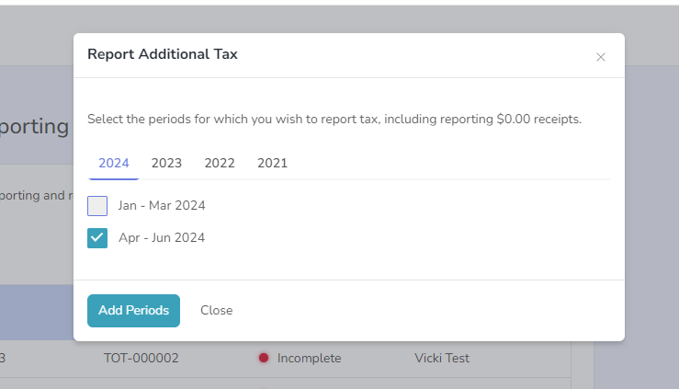

Once you have selected all of the properties and periods that you wish to report, click the Continue button.
If you have only one permit and you used the “Pay Tax” action button on the Dashboard, you will bypass the “Select Properties for Tax Reporting” screen and go straight to the Report Revenue screen. If you wish to add additional periods for reporting, clicking on the alternate “Pay Tax” button on the right-hand side of the Dashboard page will open the “Select Properties for Tax Reporting” screen which will allow you to add additional periods.
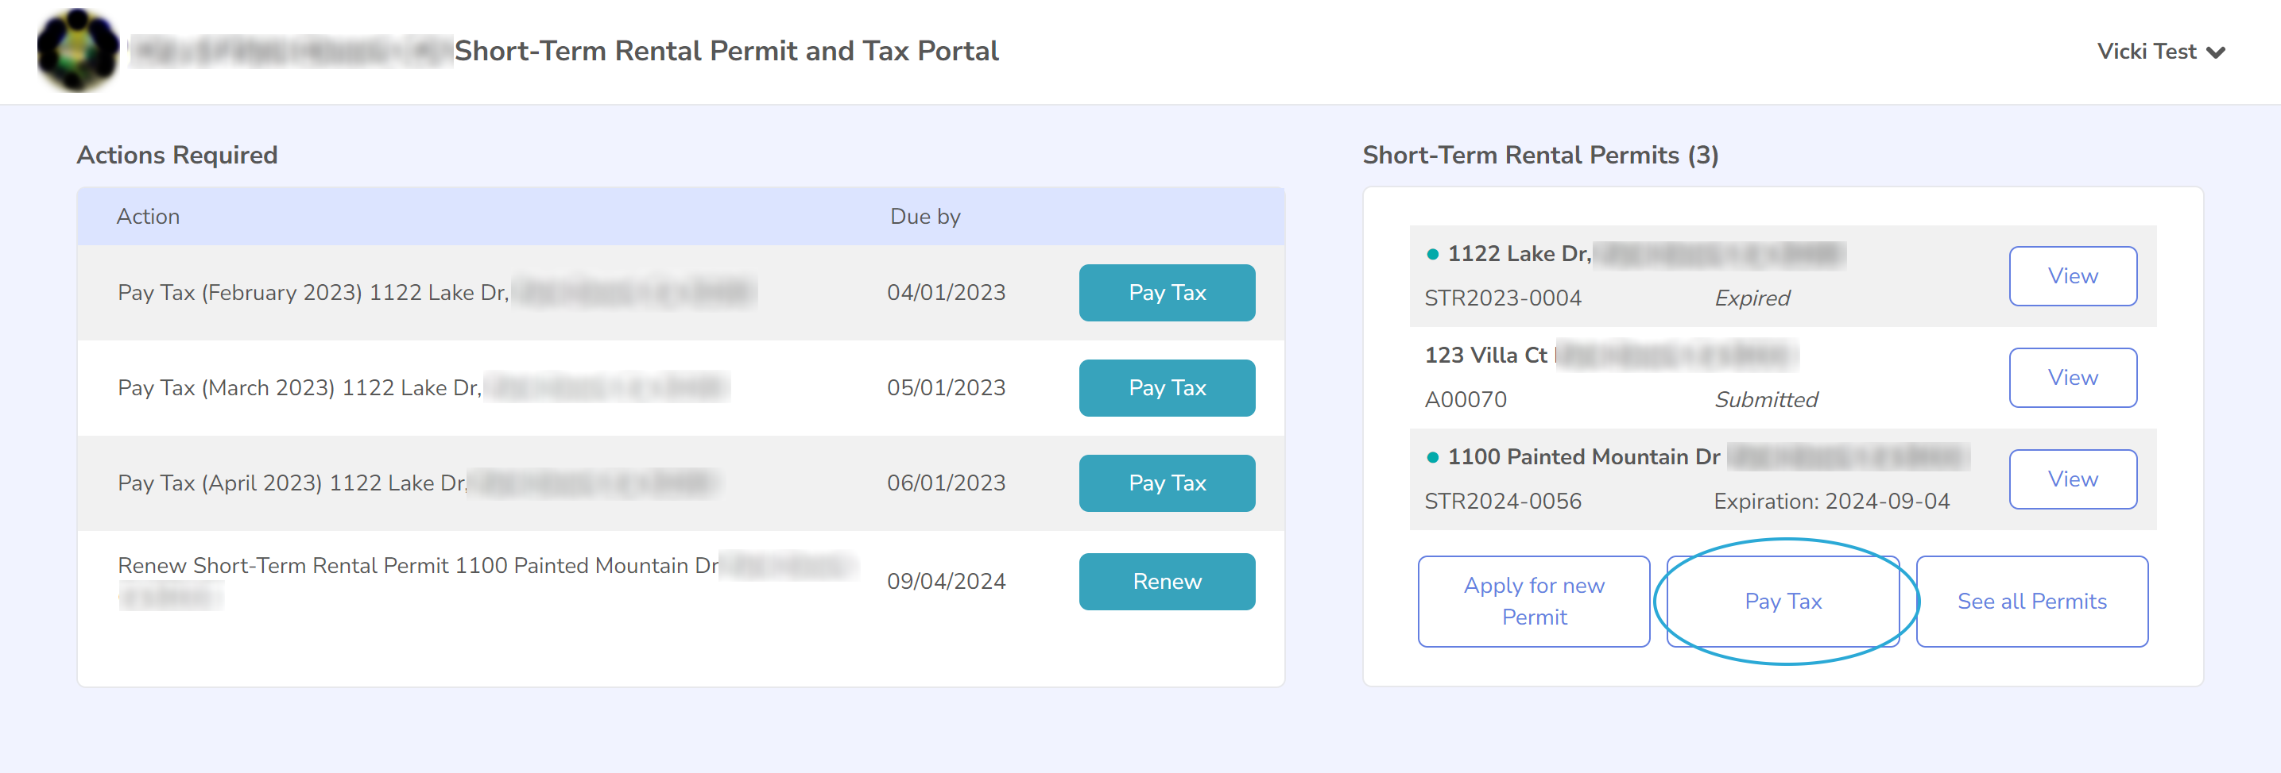

Report Revenue
Once at the “Report Revenue” page, you will be prompted to enter details for the tax reporting that is relevant to your jurisdiction, for each property and reporting period.
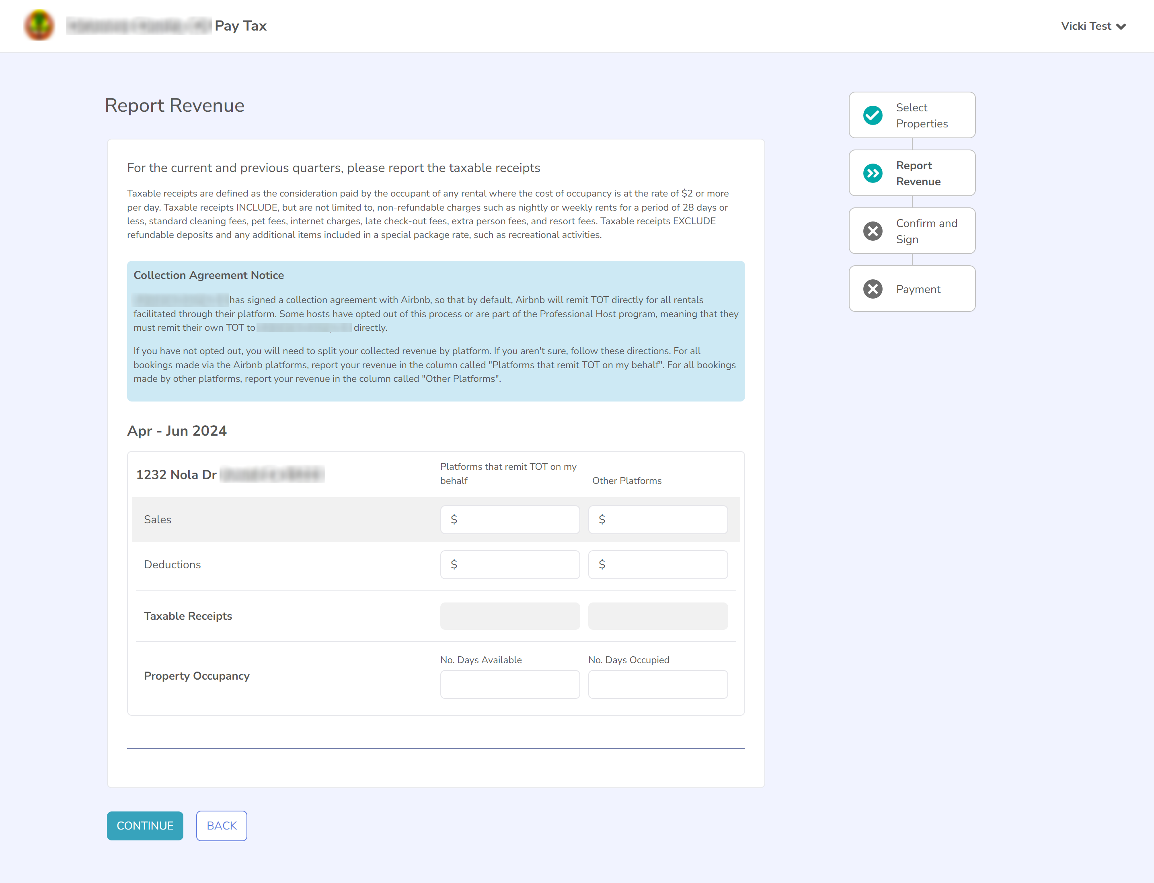

Your jurisdiction may have a Collection Agreement with Airbnb, Vrbo or other platforms. This means that the renting platform will remit the TOT (not other taxes) on your behalf. If your jurisdiction has a Collection Agreement, you will see a blue box on this screen marked “Collection Agreement Notice”, and you will see two columns in the reporting section of the page marked “Platforms that remit TOT on my behalf” and “Other Platforms”. Please read the information in the blue box carefully as it will tell you how to report correctly. The text within the blue box will tell you which platform or platforms your jurisdiction has a Collection Agreement with. If you are not part of the Professional Host program, you should report all revenue for this platform or platforms in the first column “Platforms that remit TOT on my behalf”. Any revenue for platforms not in the list should be reported in the second column marked “Other Platforms”.
An example is provided below. In this case, my jurisdiction has a Collection Agreement with the Airbnb platform only. This means that Airbnb remits TOT (but not any other applicable taxes) on my behalf. I have rented my property on multiple short-term rental platforms, including Airbnb, Vrbo and Booking.com. I have collected $3000 of revenue from Airbnb, $2000 of revenue from Vrbo, and $2000 of revenue from Booking.com and I do not have any Deductions to report.
As my jurisdiction has a Collection Agreement with Airbnb, I report my Airbnb revenue in the column marked “Platforms that remit TOT on my behalf”. I sum the revenue from the Vrbo and the Booking.com platforms together, and then I put the total revenue from those two platforms into the “Other Platforms” column. I have now correctly reported my revenue across these platforms.
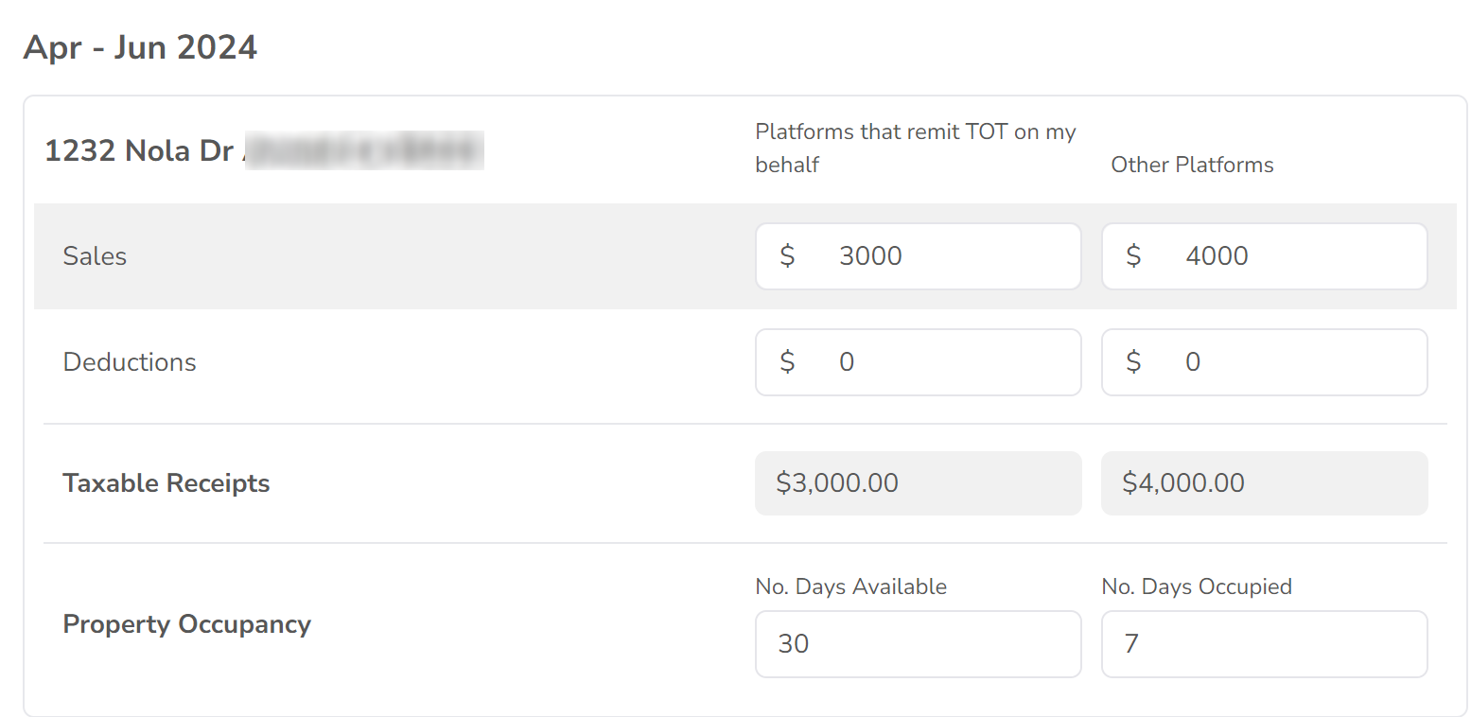

If your jurisdiction does not have any Collection Agreements, you will not see a blue box on this screen and you will see only one column marked “All Platforms”. You should report all revenue in this column.
Once you have finished reporting your revenue, click the “Continue” button at the bottom of the page to move to the next step in the process.

Confirm and Sign
On the next step in the process, you will confirm the tax/es to be remitted and certify that you have reported accurately. You will see a list of each property that you have reported for, with the calculated amount of tax payable on the right-hand side of the box.
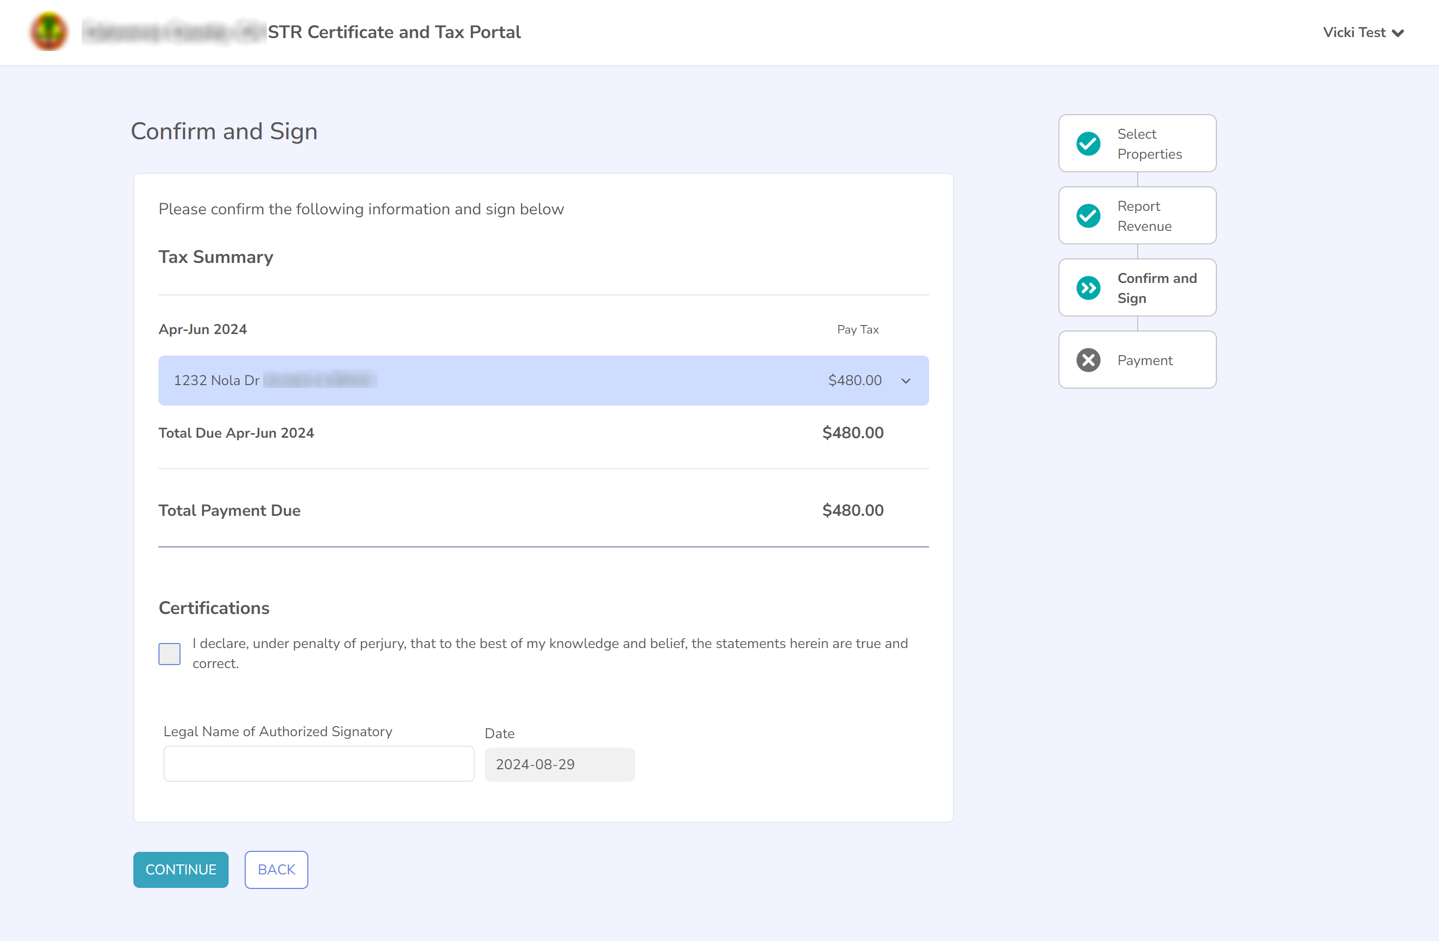

If you wish to see a full breakdown of the tax calculations, you can click on the property’s address to see the full calculation. Note that different taxes and different tax calculations apply to different jurisdictions and your jurisdiction’s taxes may be different to the one displayed here.
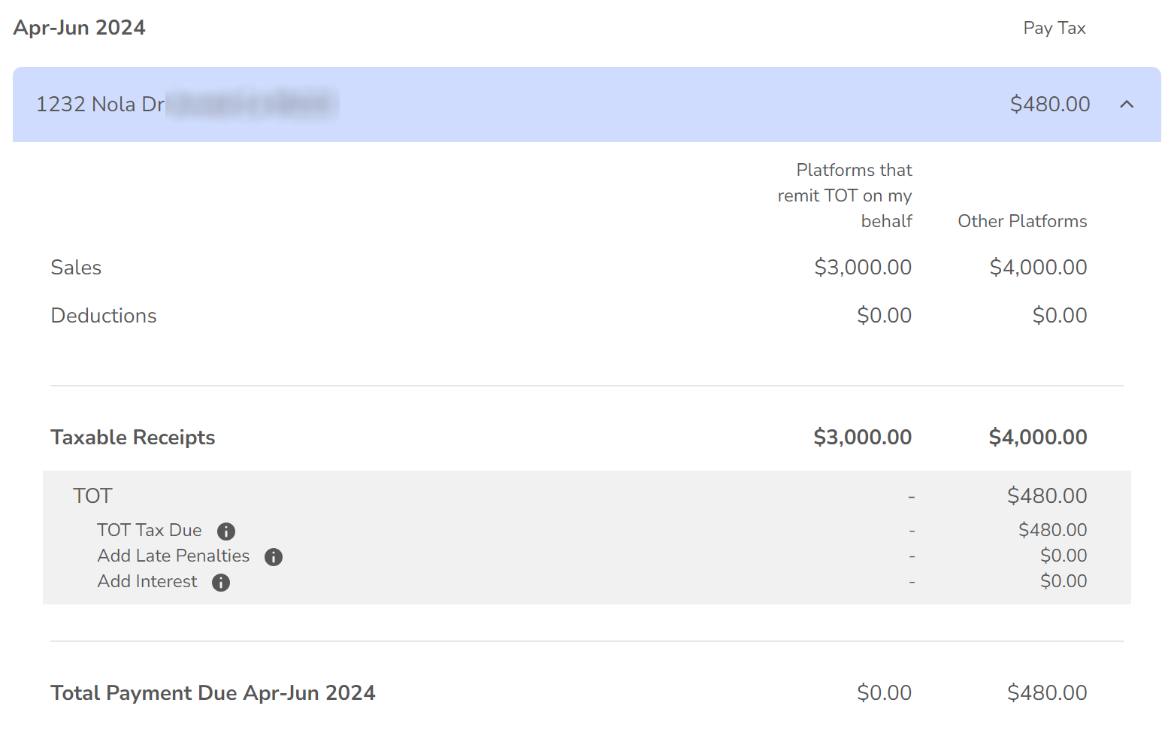
As this example is for a jurisdiction with a Collection Agreement, you can see that the calculation of TOT is blank for the “Platforms that remit TOT on my behalf” column, and TOT is only calculated for the “Other Platforms”. If multiple taxes were levied by this jurisdiction, such as both TOT and TBID, then the TBID would be levied on both columns, and the TOT would only be levied on the “Other Platforms” column.
Once you have reviewed and verified that your reporting is correct, you can certify this by checking the check-box or check-boxes at the bottom of the page and typing your legal name. Hit Continue to move to the payment page.

Payment
On the final page, you can complete payment of your required taxes through any of the payment methods offered by your jurisdiction. Once you have selected the payment method you wish to use, follow the steps to complete the payment process.
The payment process is complete once you receive a Confirmation Number and a message thanking you for submitting your tax payment. You will receive an email confirmation of your reporting details and payment.

Viewing your reporting history
If your jurisdiction requires tax reporting, you can view your reporting history for any of your permits at any time through the Customer Portal.
To view the reporting history, first find the page for the specific permit you wish to view. On the dashboard, there is a list of some of your permits on the right-hand side of the page, and clicking “View” next to the correct permit will open this page. If you cannot find the correct permit in this list, click on the “See all Permits” button below to view a full list of all of your permits. Then select “View” on the permit you wish to renew.
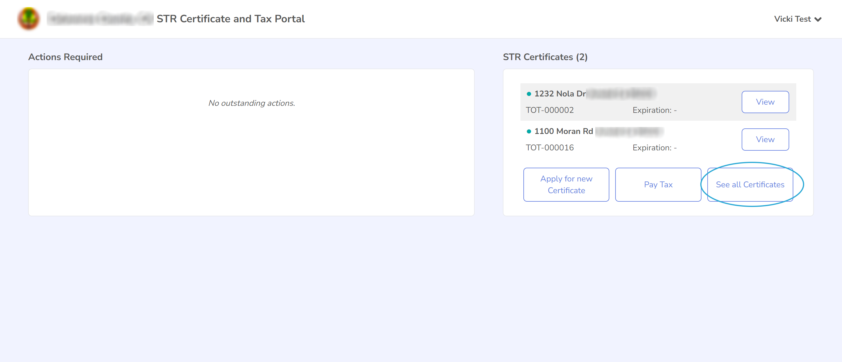

Your tax reporting history is visible on the left-hand side of the page. 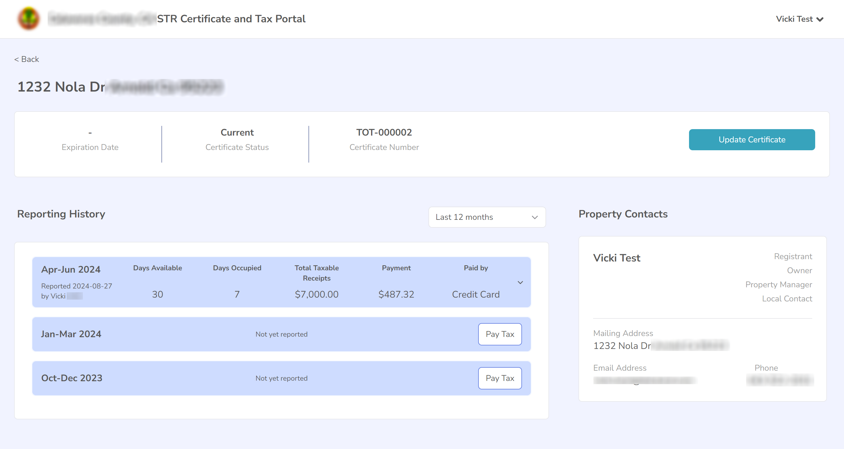

You can trigger reporting for any unreported periods by clicking the “Pay Tax” button for that period. For reported periods, you can see full details of your reporting and remittance by clicking on the reporting period. This will show the full reporting and calculation that you saw on the “Confirm and Sign” page while reporting your taxes.
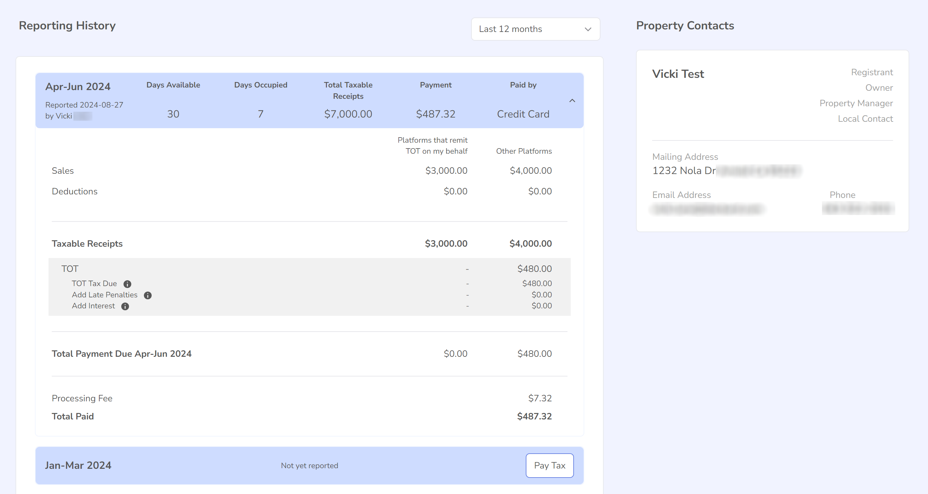

Getting additional help
If you need further assistance, please contact the staff of your jurisdiction.

