

Fort Myers Beach
Leadership Strategic Planning Discussion

December 16, 2025

Meeting Notes

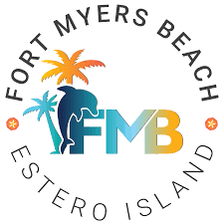

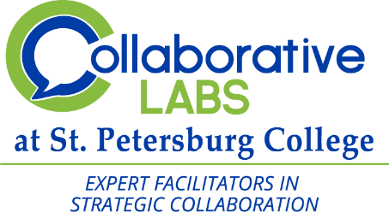



Table of Contents
Agenda 3
Project Overview & Approach 4
Refining Our Vision, Mission, Core Values 4
Vision 4
Mission 4
Refining Core Values 5
Refining Key Strategic Themes 5
Identifying Goals 5
Next Steps 6
Attendees 6

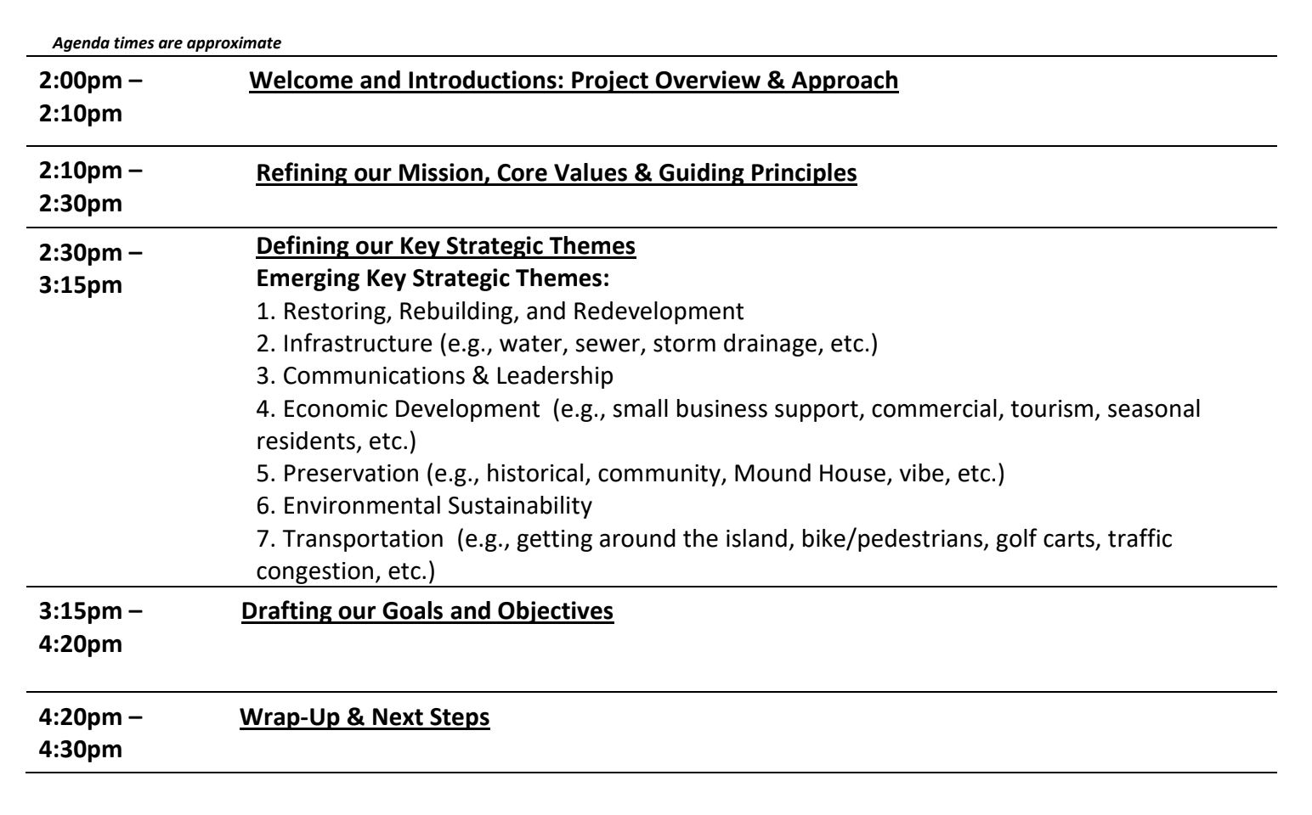
Agenda

Project Overview & Approach
Angela: To move forward with the Strategic Plan, participants are going to do a bit of work to present the document to the Council. The Strategic definitions have been included in the packet as a reminder.

The plan for today:
  - Refine our Mission, Vision, Core Values
  - Define the Key Strategic Themes
  - Identify the Goals and Objectives
Refining Our Vision, Mission, Core Values
Vision
- Angela reviewed the top picks for vision statements and requested feedback.
- Angela recommended making the vision a little tighter, shorter with fewer words.
- This vision should be a long-term resource. Words that time limit the vision should be removed.
- Participants discussed wordsmithing the vision.
- Participants discussed changing the name of the town.
- Eclectic, coastal community, island life, and small town were discussed as important descriptors.
- Experience vs. enjoy, thrive, prosper were discussed as the visionary verbs.
- Live long and prosper.
Mission
- Angela reviewed the top picks for the mission statement.
- Angela emphasized that this statement represents why the town exists.
- This should be simple and concise.
- The mission should never stand alone. The vision should never stand alone. They should always be together.
- Participants word smithed the mission.
- Angela recommended that words like communication, transparency, and servant leadership should be recommended by the core values.
- Angela reviewed the original examples given to the council.
- Angela put the edited vision and mission for side-by-side review.

Refining Core Values
- Angela reviewed the process that produced the vision, mission, and core values.
- Participants went one by one through the core values to look for opportunities to condense and combine down from the existing seven.
- Participants went through each core value to define their meaning.
- Participants discussed integrating servant leadership and collaboration into other core values.
- Participants settled on six core values:
  - Stewardship
  - Mutual Respect & Civility
  - Accountability
  - Resiliency
  - Transparency
  - Preservation
Refining Key Strategic Themes
- Participants reviewed and discussed the current key strategic themes.
- Participants discussed each of the underlying definitions encompassed in each strategic theme.
- Participants identified potential underlying goals and objectives for themes as they reviewed them.
- Participants looked for synergies and combination opportunities.
- Participants discussed moving Transportation under Infrastructure.
- Participants discussed how to message planning, RRR (Restoring, Rebuilding, and Redevelopment), preservation community, and economic development.
- Discussed changing Economic Development to Community & Economic Development and put RRR under it.
- Participants will move forward with the above structure and if it is too big, they will revisit expanding into another theme.
- Angela strongly recommends not having more than five strategic themes.
Identifying Goals
- Angela reviewed the definition of a strategic goal.
- Participants identified goals under each theme.
- Participants went through a process of identifying desired future outcomes to define each strategic goal.
- Participants began identifying potential objectives as they discussed goals.
- Participants discussed exhaustive lists of what goals could fall under each theme.

Next Steps
- The USF and SPC teams will edit the documents for Leadership’s review.
- Angela asks that participants get into the documents to continue review and editing
- The edited drafts will continue to be drafted on January 7th.
- Angela proposed the Council Workshop be held on February 5th.
Attendees
- Will McKannay – Town Manager
- Joe Onzick – Finance
- Jeff Hauge – Community Services
- Frankie Kropacek/Georgina Cid – Community Development
- Amy Baker – Town Clerk
- Traci Kohler – Deputy Town Manager
- Thomas Yozzo – Emergency Services (ABSENT)
- Talissa Oliveira – Human Resources

