Matanzas Harbor Municipal Mooring Field
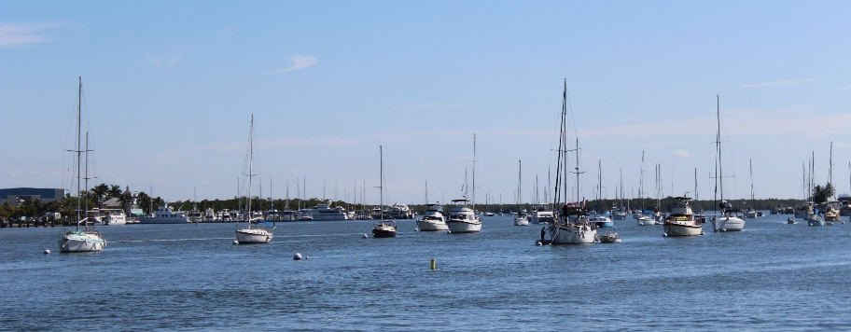
Strategic Action Plan
October 21, 2020
Amended: Feb. 16, 2022

Developed by Mooring Field AAC, Staff, and Stakeholders
MOORING FIELD MISSION
Provide a safe and welcoming
experience for mariners.

MOORING FIELD VISION
To be the preferred mooring
destination in Florida.

FMB MOORING FIELD SUCCESS STANDARDS
- We provide exceptional customer service in an efficient and knowledgeable manner.
- We provide an attractive, safe, and comfortable destination.
- We provide exceptional and well-maintained amenities.
- We are attracting new customers and retaining repeat customers.
- We have fluent and open communication between customers, town staff, provider, and AAC.

Strategic Action Plan
October 21, 2020

CORE FOCUS AREA | STRATEGIC OBJECTIVES
1. CUSTOMER EXPERIENCE | Short Term Goals | Responsibility | Target Date | Progress Report
 | 1. Identify ways to create a positive experience that appeals to all boaters and consider feasibility for implementation. | Randy | 7/1/2022 | Continuous
 | 2. Explore the possibility of quick action to separate the restroom from the restroom/shower facilities with current provider. | Town | 2/1/2023
 | Long Term Goals
 | 3. Provide ongoing customer service training specific to the Mooring Field, to all stakeholders and staff. | Randy | 6/1/2022 | Continuous
2. GROWTH / CAPACITY | Short Term Goals | Responsibility | Target Date | Progress Report
 | 1. Move forward with plans to expand existing mooring field. | PW Direc./Austin | 2/1/2023 | Ongoing
 | 2. Work to expand the number of restroom and shower facilities. | PW Direc./Town | 2/1/2023 | Ongoing
 | 3. Work to expand dinghy dock capacity. | Austin | 8/1/2022 | Ongoing
 | 4. Identify an appropriate outdoor congregation space for Mooring Field customers. | PW Direc./Town | 2/1/2023 | Ongoing
 | 5. In expansion planning, ensure the Mooring Field can accommodate all vessels (within our legal capability.) | CEC/PW Direc. | 2/1/2023
 | Long Term Goals
 | 6. Consider the pros and cons of a Ship Store and make a recommendation on whether to pursue. | AAC | 10/1/2022
 | 7. Create an appropriate indoor congregation space for Mooring Field customers. | Town | 3/1/2022 | Completed-Mooring Field Office
 | 8. Increase the occupancy of the Mooring Field to maximize utilization. | Town | 2/1/2023 | Ongoing
 | 9. Assess need for staff increases in future initiatives. | PW Dir./Austin | 12/1/2022 | Ongoing
 | 10. Continue work to become a designated federal anchorage area. | CEC/PW Direc. | 9/1/2022
 | 11. Consider options for Mooring Field vehicle parking spaces. | Randy | 8/1/2023 | Ongoing
3. TECHNOLOGY IMPROVEMENTS | Short Term Goals | Responsibility | Target Date | Progress Report
 | 1. Create an on-line solution to create efficiency and ease for customers (to include check-in, check-out, waiting list management, and pump out requests). | PW Direc./Austin | 2/1/2022 | Completed
 | 2. Set up a kiosk dedicated to check-ins. | Randy/IT | 7/1/2021 | Completed
 | 3. Acquire Wi-Fi access for entire area of Mooring Field. | Randy/IT | 7/1/2023 | Ongoing
 | 4. Create a social media presence to market and inform. | PIO | 5/1/2022 | Ongoing
 | 5. Research best solution to employ sensor notification for tracking mooring ball occupancy. | Randy/IT | 4/1/2023 | Ongoing
 | Long Term Goals
 | 6. Install Key Card technology for use of bath/shower facilities. | PW Direc./IT | 7/1/2021 | Completed
 | 7. Create a FMB Mooring Field app for use by customers. | PIO | 8/1/2021 | Completed
 | Short Term Goals | Responsibility | Target Date | Progress Report
4. SAFETY AND SECURITY | 1. Implement fender improvements at dinghy dock. | Austin | 2/1/2021 | Completed
 | 2. Install security cameras at dinghy dock and restroom entrances. | PW Director | 4/1/2023 | Camera in office
 | 3. Ensure restroom/shower facilities are meeting maintenance standards for customer safety. | Austin | 6/1/2022 | Ongoing
 | 4. Meet with law enforcement to agree on proactive measures that includes flow of information to assist in ensuring safety and security. | Austin | 10/1/2022 | Ongoing
 | 5. Improve the lighting and the dinghy dock and all usage areas. | PW Director/Austin | 12/1/2022 | Ongoing
 | Long Term Goals
 | Short Term Goals | Responsibility | Target Date | Progress Report
5. COMMUNICATION | 1. Enhance communication to customers. | Town | 10/1/2022 | Ongoing-Dockwa/Customer Service
 | 2. Define a process for regular and specific updates between the AAC and Town Council. | AAC/Liaison | 1/1/2021 | Completed
 | 3. Define a process for regular and specific budget reports from staff to AAC (including the State Report). | Finance | 5/1/2022
 | 4. Develop a fully implementable marketing plan. | PIO/PW Direc. | 7/1/2022
 | 5. Investigate feasibility and value of conducting a monthly meet and greet for customers. | Town | 12/1/2023
 | 6. Create a verbal communication log for use in following up on shared information from customers. | Town | 8/1/2022 | Ongoing-Dockwa/Customer Service
 | 7. Create a center for communication of rules, events, plans, and other information of interest to customers (signages). | Austin | 6/1/2022 | Ongoing-Dockwa
 | Long Term Goals
 | 8. Ensure there is fluent and open communication between customers, Town Council, Town Staff and AAC. | PW Director | 10/1/2022

